|  |
| --- |
| Faculty of Engineering and Technology  **Development of an industrial automation architecture using open-sourced hardware & software – Industry 4.0**  The bachelor thesis document for the bachelor assignment “Development of an industrial automation architecture using open-sourced hardware & software – Industry 4.0”.  Andre N.K. Kansa - ID 168356 – Automation Engineer Bachelor  kansaandre@gmail.com / +4746808793  **AUT-2780-1, Autumn 2023**  **VERSION 1.0 | Last Updated: 14.05.2023**  **Confidentiality: Open (GNU GPL v3)** |



**Project report – Page 2**

|  |  |  |  |
| --- | --- | --- | --- |
| **Study Program:** | **S ss** Automation EngineeringBachelor | **Year:** | 2023 |

|  |  |  |
| --- | --- | --- |
| **Title:**  Development of an industrial automation architecture using open-sourced hardware & software – Industry 4.0 | | **Date:**  14.05.2023  **Confidentiality:**  Open (GNU GPL v3)  **Pages:** 68 (including front page etc.)  **Appendix:**  3 (A, B and C) |
| **Author:**  Andre Nikolai Kristoffersen Kansa | |
| **Supervisor:**  Endre Grimstad at UIT | | |
| **Employer:**  Abatik Thermo AS | **Contact person of employer:**  Thomas Klemmetsen | |

|  |
| --- |
| **Summary:**  This project report details the creation and assessment of an open-source industrial automation architecture designed for scalable, cost-effective, and accessible solutions in various applications. The architecture addresses traditional systems' limitations by utilizing open-source technologies like Raspberry Pi, Arduino, Dgraph, Node-RED, and Arduino IDE. The system offers remote control, easy updates without shutdowns, and adaptability for various industrial processes.  The first iteration achieved several goals, but some objectives remain unmet, which will be addressed in future iterations. Tested in a simulated small process plant, the architecture demonstrates its potential as a disruptive, cost-effective alternative to traditional systems, fostering innovation and collaboration in the industry.  Serving as a thesis for UIT and a resource on GitHub, the architecture encourages global community contributions and is organized into functional layers. Future iterations will focus on refining the system and improving performance for a wide range of applications, benefiting from the open-source approach's continuous development and collaboration. |
| **Keywords:** Open-Source, Industrial-Automation-Architecture, Human-Machine-Interface, Raspberry-Pi, Arduino, Dgraph, Node-RED, Control-System, Process-Control, Batch-Control. |

Abstract

This comprehensive project report presents the development, implementation, and evaluation of an open-source industrial automation architecture, designed to offer a scalable, cost-effective, and accessible solution for various industrial applications. The architecture was specifically developed to address the challenges and limitations of traditional automation systems, which often rely on expensive, proprietary hardware and software and can be complex to implement, troubleshoot, and maintain.

In the first iteration (v1.0 & i1.0), the project achieved several goals such as providing an interactive process operator GUI, supporting remote control capabilities, and proving suitable for both small and large-scale automation projects. However, some goals were not met, including implementing a data storage layer using Dgraph and updating the solution without shutdowns. In the next iterations, the focus will be on addressing these unmet goals, applying lessons learned, and refining the approach to develop a more robust and versatile industrial automation architecture.

The proposed solution brings together a combination of widely-adopted open-source technologies, including Raspberry Pi and Arduino platforms for hardware, along with Dgraph, Node-RED, and Arduino IDE for software, creating a comprehensive and versatile system for industrial automation.

Tested on a simulated small process plant, the developed architecture demonstrated its potential to provide a viable and cost-effective alternative to traditional systems. With a strong emphasis on its open-source nature and community-driven approach, the project fosters innovation, flexibility, and collaboration in addressing the evolving needs and challenges of the industry, while offering substantial cost savings and increased efficiency for companies looking to automate their processes.

This document serves as both a thesis for UIT and a valuable resource available on GitHub, encouraging a global community of contributors to participate, iterate, and build upon the architecture's capabilities. The architecture is organized into several layers, such as the process layer, control layer, Human Machine Interface (HMI) layer, and data store layer, each designed to serve specific functions in the industrial automation process.

Future iterations of the project will focus on refining the system, improving performance and functionality, and applying the lessons learned from the initial development to create more robust and adaptable solutions for a wide range of industrial applications. The open-source approach allows for continuous refinement and collaborative problem-solving, enabling the system to evolve and address identified challenges more effectively.

Declaration

I declare that this document is an original work of my own authorship and that it fulfils all the requirements of the Code of Conduct and Good Practices of University of Tromsø.

Acknowledgement

Major thanks to my professors at University of Tromsø who have taught me a lot the last couple of years. The things I have learned the last years include learning that I know little. But I have been given a solid base from UIT from which I have relied heavily on during the writing of the thesis. Also, a huge thanks to my supervisors, assoc. prof. Endre Grimsbø, which helped me keep on track and move the thesis in the right direction. I would like to thank my wife, Júlia, for helping me, as well as my family, friends, and others who have made it possible for me to pursue education to the level I have, which for me would not be possible without having the support I had. And lastly, a major thanks to the whole scientific community for all that you do, and do so greatly, every day. Without the community of researchers, programmers, engineers, teachers, mathematicians, physicists, and skilled workers who have published data from every corner of the world for centuries this thesis would not be possible to write. Truly standing on the shoulders of giants.

Confidentiality and Licensing

This bachelor thesis and all associated code and software found in the GITHUB repository are subject to certain confidentiality and licensing terms. It is important that readers of this document understand these terms to avoid any legal issues.

Confidentiality Statement: This bachelor thesis contains confidential information that is solely intended for the reader of this document. Any unauthorized reproduction, distribution, or modification of this work or associated code and software is strictly prohibited and may result in legal action.

Licensing Statement: The code and software used in this thesis are released under the GNU General Public License v3.0 (GPL v3). This license grants the reader the freedom to use, distribute, and modify the code and software, as long as they abide by the terms of the license. The GPL v3 requires that any modifications made to the code or software must also be released under the same license, thereby promoting the open sharing and collaboration of code and software.

Furthermore, this bachelor thesis itself is also released under the GPL v3, which means that readers are free to use, modify and distribute the thesis, but they must also follow the terms of the license. This includes ensuring that any modifications made to the thesis are also released under the same license.

In practical terms, the GPL v3 provides a legal framework for the open sharing and collaboration of code and software, while also protecting the rights of the original author. Readers are free to study and build upon the work, but they must also contribute any modifications they make back to the original project under the same license, helping the community. By reading this document, you acknowledge that you understand and agree to these confidentiality and licensing terms. If you have any questions or concerns, please do not hesitate to contact the author.

GitHub repository goal

The purpose of sharing this document and data is to establish a general open-source architecture for industrial automation. Version 1.0 serves as an example of how to set up a process control or industrial case using open-source solutions that work together. Moving forward, the goal is to have more people contribute to the project, creating their own versions and iterations with their own cases and examples. Eventually, the hope is to develop a more general system that is easier to implement, while still allowing for customization to fit specific industrial problems. This stands in contrast to many industrial solution vendors that offer little to no customization options.

Thesis citation and figure style format

In this thesis, we have chosen to use the APA style for both citation and figure text formatting. This decision deviates from the UIT default figure text formatting; however, the author believes that maintaining a consistent standard throughout the document is more beneficial and outweighs the need to adhere to the default options. By adopting the APA style consistently, we ensure a coherent and professional presentation of the thesis.

Contents

1 Document & Project - structure 9

2 Introduction 10

2.1 Background for thesis 10

2.2 Industry 4.0 11

2.3 Software 13

2.4 Hardware 15

2.5 Relevance 17

2.6 Problem to solve 18

2.7 Industrial automation architecture 19

2.8 Goal formulation (planned solution for version 1.0) 22

2.8.1 Dgraph (planned use in Data Storage Layer (database)) 23

2.8.2 Raspberry Pi (planned use in HMI/SCADA Layer) 23

2.8.3 Node-Red 24

2.8.4 Arduino 24

2.8.5 Requirements 26

2.9 Hardware in stock 27

2.10 Project plan for thesis deadlines 28

3 Methodology 29

4 Literature review 29

5 Iteration 1.0 (v1.0 & i1.0) of solution 32

5.1 Control Layer (Arduino) 32

5.1.1 Overview 32

5.1.2 Imaginary process – Batch-process 33

5.1.3 Choice of IDE 36

5.1.4 Objective of the Control Layer Logic 38

5.1.5 Implementation of code in the Control Layer 42

5.2 HMI Layer (Node-RED) 47

5.2.1 Overview 47

5.2.2 Objective of the HMI Layer Logic 47

5.2.3 How the GUI was made 48

5.2.4 GUI 49

5.2.5 GUI script description 50

5.3 Process Layer (Node-RED) 53

5.3.1 Overview 53

5.3.2 Objective of the Process Layer 53

5.3.3 Process simulation description 54

5.4 Reflection for next iterations 56

5.4.1 Report of iteration 1.0 version 1.0 (v1.0 & i1.0) 56

6 Environmental Impact Analysis 59

7 Conclusion of thesis 60

8 How to participate / How to run repository data 61

8.1 Guide 61

8.2 Guidelines 62

9 Bibliography 64

Appendix 66

A. Project Reflection 66

B. Control Layer (Arduino) Code for v1.0 & i1.0 68

C. HMI/SCADA Layer (Node-Red) Code for v1.0 & i1.0 69

# Document & Project - structure

This document is divided into Group A and Group B, adopting an iterative process that resembles a story rather than a technical datasheet. Group A includes details about the project, such as its purpose, objectives, and the desired end goal for the current version (e.g., version 1.0). Contributors can modify Group A by creating a separate document, saving the original with the filename "Version x.x" in the GitHub document folder, and then generating a new document with the updated version number. The latest version document is accessible on the repository's front page, while older versions are stored in the document folder. This process applies only to the main branch; other branches may follow different setups as they please.

Group B concentrates on iterations, progressive steps aimed at achieving the goals outlined in Group A. Each version has multiple associated iterations, working towards the objectives set for that version. These iterations may partially achieve the overall goal, improve upon previous iterations by fixing design flaws or moving closer to the ideal solution, or address minor issues like bug fixes or small refinements.

The document begins with assumptions and advances towards a solution, refining and correcting design choices as it progresses. This iterative approach offers valuable insights into each design choice and its rationale, making the document more engaging and comprehensible for readers. Although unconventional in some scientific communities, the author believes this method provides better guidance and readability for a design process.

The version and its given iterations are identified using a specific labeling format, such as "v1.0 & i1.0". In this example for iterations, i1.0, the "1" represents a major change, like a new approach or significant design update, while "0" indicates smaller modifications, such as corrections and bug fixes. The version number is also included for easy reference to the corresponding goals and requirements in Group A. Every time the goals/requirements or change of hardware/software configuration are made a new version number must be made. The impact and changes required define if it will be a major change or smaller change and if the ones or the tenths place must be changed accordingly to highlight this update of Group A.

To improve the association between the document and data (e.g., Arduino, Node-RED, etc.) with their respective versions and iterations each "thesis" document displays a version, and each version (document) has one or many iterations. For data associated with a document, the version number is written first, followed by the iteration it is part of. For example, data made for Group A version 1.0 in Group B iteration 2.0 would be labeled "v1.0 & i2.0".

# Introduction

## Background for thesis

The background for writing the bachelor thesis on "Development of an industrial automation architecture using open-sourced hardware & software – Industry 4.0" is rooted in the necessity for an efficient, flexible, and cost-effective control system for another project the author was working on, a master thesis which focused on creating a new method for obtaining heat from the soil in arctic conditions for use with a ground-sourced heat pump.

A suitable control system is required for this heat pump project, which is capable of reading inputs from sensors, writing outputs to actuators, displaying values accessible to authorized users within the Local Area Network (LAN), and allowing remote access through VPN. Additionally, it should be capable of accepting user input, reacting accordingly, and storing values in a database for historical data tracking, research, troubleshooting, and data plotting.

Traditional proprietary control systems often come with expensive license fees and are rigid in design, also as documentation/source-code are closed by nature which also making them difficult to debug without hiring professionals from the respective companies. In light of these drawbacks, the decision was made to develop an industrial automation architecture using open-source hardware and software. This project aims to create a control system that is versatile, cost-effective, and more accessible for users.

By exploring the possibilities of Industry 4.0 using open-sourced hardware and software, this thesis seeks to develop an industrial automation architecture suitable for both small and large-scale applications, such as home gardening and larger process plants. The focus is on creating a system with built-in connectivity to the internet and remote access capabilities from the beginning, allowing for seamless integration and monitoring.

The successful development of this control system would not only benefit the master thesis project but could also be extended to other applications in various industries. This approach aligns with the growing trend of Industry 4.0, which emphasizes the integration of internet connectivity, remote access, and open-source technologies to improve overall efficiency and flexibility in industrial processes.

## Industry 4.0

Industry 4.0, or the Fourth Industrial Revolution, is the current era of technological advancements in manufacturing and industry. It builds on previous industrial revolutions by integrating digital technologies, automation, and data exchange to create interconnected systems.

Industry 1.0 began in the late 18th century with steam and water-powered mechanization, while Industry 2.0 emerged in the late 19th and early 20th centuries with electricity and mass production. Industry 3.0 arrived in the late 20th century, incorporating computers and automation into industrial processes.

Industry 4.0 converges digital technologies, automation, and connectivity, including the Internet of Things (IoT), artificial intelligence (AI), advanced analytics, robotics, as well as additive manufacturing. Industrial automation is crucial in optimizing production processes and worker safety.

IoT connects physical objects, machines, and sensors, while AI technologies, such as machine learning, autonomously optimize processes. Advanced analytics help manufacturers uncover patterns and optimize operations. Decentralized industrial automation architecture incorporates edge and cloud computing for data processing and collaboration.

Our project, focused on developing an open-source industrial automation architecture, is closely related to Industry 4.0, which integrates digital technologies, automation, and data exchange to create interconnected systems. We leverage the Internet of Things (IoT) and artificial intelligence (AI) to enhance our architecture.

IoT connects devices and systems, enabling remote access and control. We utilize Node-RED for IoT applications and Raspberry Pi for versatile open-source hardware. AI accelerates development by accessing vast resources from forums, openstack, GitHub, and more, optimizing operations through pattern recognition and data analysis.

The industrial automation architecture employs open-source software and hardware such as Dgraph, Raspberry Pi, Node-RED, Arduino, and Arduino OPTA, embodying Industry 4.0 principles with scalable, cost-effective, and versatile solutions. Decentralized industrial automation architecture allows for data processing and collaboration through edge and cloud computing.

In summary, our project harnesses IoT and AI to create innovative, data-driven solutions for improving efficiency across various applications, contributing to the progress of Industry 4.0 and making cutting-edge technologies more accessible and versatile across the industry.

## Software

According to EnterpriseAppsToday.com (2022), open source-based software already controls 96.3 % of the world’s top web servers as Linux, the most famous and popular open-source software, is used as the operating system. The Linux kernel was developed by Linus Torvalds in 1991 who was a science student at the University of Helsinki in Finland at the time, it was a personal project with the goal of creating a free, open-source operating system that would be compatible with UNIX which we will come back to later. Open-sourced software is now very popular and widely used in the programmers and developer world, but it was not always the case. In the past, Bill Gates, co-founder of Microsoft, has made statements critical of open-source software, particularly in the late 1990s and early 2000s. He was quoted as saying that "Linux is a cancer that attaches itself in an intellectual property sense to everything it touches" in 2001 and that open-source software would "create a vacuum" in the software industry.

However, in recent years, Microsoft has shifted its stance on open-source software and has begun embracing it in various ways. Bill Gates himself also acknowledged that the company's attitude towards open-source has changed. He said "Microsoft is not anti-Linux, anti-open-source. We are pro-Windows and pro-Microsoft.". Below a couple of examples of how Microsoft is toward open source today:

* Azure Cloud: Microsoft's Azure cloud platform supports a variety of Linux distributions, including Ubuntu, Red Hat, and SUSE. Customers can use these Linux distributions to run their applications on Azure, and Microsoft provides support for them.
* .NET: Microsoft developed and open-sourced the .NET framework, a development platform for building web and mobile applications. The platform is available under an open-source license and is supported by Microsoft.
* Visual Studio Code: Microsoft's popular code editor, Visual Studio Code, is open-source and available for Windows, Linux and Mac. It's a widely used tool among developers and it's under the MIT license.
* SQL Server: Microsoft's SQL Server has a version that runs on Linux. It provides the same features as the Windows version of SQL Server, and it's available under an open-source license.
* GitHub: Microsoft acquired GitHub, the world's largest code repository and a platform for open-source collaboration in 2018, and continues to use it to host a variety of open-source projects. GitHub is a web-based platform for version control and collaboration that uses Git as its underlying technology. Git is an open-source, distributed version control system that was created by Linus Torvalds in 2005, creator of the Linux kernel. It allows developers to track changes in their code and collaborate on projects with other developers
* Microsoft Edge: Microsoft's web browser, Edge, is built on the Chromium open-source project, which is a foundation for Google's Chrome browser.

Although today the situation toward open source is very positive in the software development side, it has not always been the case as could be assumed from Bill Gate’s quote from 2001. Especially in the beginning there have been multiple legal fights to keep open-source development halted.

In 1971 UNIX was released by Bell Labs which in turn is owned by AT&T and Berkeley Software Distribution (BSD) was first developed in the late 1970s and early 1980s at the University of California, Berkeley. They are both operating systems based on the original UNIX code, but BSD includes additional features and improvements such as TCP/IP networking stack. UNIX is proprietary and its source code is not freely available, while BSD is open source, with freely available source code, and can be modified and distributed without legal or licensing restrictions. The main difference between UNIX and BSD is the legal aspect of it. In the early 1990s, AT&T filed a lawsuit against the University of California claiming that Berkeley Software Distribution (BSD) version of UNIX had violated AT&T's intellectual property rights by using code from the original UNIX operating system without permission. The court ruled in favor of AT&T in 1995 and as a result, BSD developers were required to remove any code taken from UNIX and pay license fee to AT&T.

As an indirect result of this legal dispute with UNIX and the attack on open source, a programmer named Richard Stallman at Massachusetts Institute of Technology (MIT) started developing the GNU Project, GNU being the acronym for “GNU's Not Unix!”. It provided a foundation for the development of the Linux operating system, which combined the GNU components with the Linux kernel. This combination created a fully functional operating system that could be used as a free and open-source alternative to UNIX and BSD. It is this collaboration between these open-source giants that made Linux OS to what it is today.

## Hardware

Open source hardware is not nearly as popular as open source software. Open-source software has had large communities for decades while open-source hardware has lagged behind in terms of adoption and development. This is because creating and manufacturing hardware is more complex and costly than creating software. Additionally, the open-source hardware movement is still relatively new and not as well established as the open-source software movement.

Open-source hardware first started to gain mainstream attention during the 2000s. In 2005 the Open Hardware Definition document was proposed by a group of engineers, designers, and educators which defines the characteristics of open-source hardware, and it has since been adopted by the open-source hardware community as the standard definition of open-source hardware. The definition states that open-source hardware must be freely available for anyone to use, modify, and distribute, and that any changes made to the design must be shared with the community. The definition also requires that the design must be fully documented, and that it should be possible to make and sell products based on the design. In 2010 the first Open Hardware Summit (OHS) was held, today OHS is an annual conference that brings together engineers, designers, educators, students, makers, business leaders, and other experts to discuss the latest developments, challenges, and opportunities in the field of open-source hardware.

Despite these challenges, the open-source hardware movement is gaining momentum and has the potential to change the way hardware is designed, produced, and distributed. It's also becoming more mainstream. Today there exists many popular open-source hardware projects as:

* Arduino: An open-source microcontroller platform that is widely used for building electronics projects.
* Raspberry Pi: A small, low-cost computer that is popular among hobbyists and educators.
* RepRap: An open-source 3D printer that can be used to print parts for other machines.
* BeagleBone: A small, low-cost single-board computer that is popular among hobbyists and educators.
* Adafruit: A company that designs and sells open-source electronics and components, often used in DIY projects.
* OpenAI's Open Source Hardware: OpenAI is open sourcing its hardware designs, including the power supply, motherboard, and chassis for its machine learning hardware, to encourage collaboration and innovation in the field.
* OpenSPARC: An open-source implementation of the SPARC architecture, which is used in many high-performance computing systems.
* OpenRISC: an open-source processor architecture for embedded systems.

## Relevance

Open source has not yet become embraced by classic industries (petroleum, breweries etc.) due to multiple concerns including:

* Lack of understanding: Many people in these industries may not be familiar with open-source concepts and the benefits they can provide.
* Fear of losing control: Some companies may be hesitant to adopt open-source solutions because they are worried about losing control of their technology or intellectual property.
* Reliance on proprietary solutions: Many companies in these industries have invested heavily in proprietary software and hardware and may be hesitant to switch to open-source alternatives.
* Legal and regulatory concerns: Some companies may be concerned about the legal and regulatory implications of using open-source software and hardware, such as issues related to licensing and liability.
* Fear of security threats: Companies may be concerned about the security risks associated with open-source software, despite it being open for security experts to scrutinize.
* Lack of support: Companies may be hesitant to adopt open-source solutions because they are not sure who will provide support and maintenance.

In the thesis these concerns will be challenged, and a solution made from open source software combined with open source hardware will be created with documentation, debugging and community a proprietary solution could dream of. Many industries seem very concerned with the lack of having a single “contact” when things must be maintained and/or changed. Today there exist many companies that specialize in giving industries the 24/7 professional support of open-source software and hardware if they so want it. It also exists open-source hardware and software that have operated for decades with continuous improvement.

The larger the community the more refined and polished products. “Linus’s law” which states "Given enough eyeballs, all bugs are shallow", is a quote made from Linus Torvald one of the giants in open source highlight a very important thing. The large communities actively working together will find and/or experience all security threats and all bugs that exist.

Its open code, documentation etc. makes it possible for anyone to view everything, and if enough eyes are viewing the same thing, one will find all problems as well as improvements.

## Problem to solve

The problem this thesis will look into is how one could make an industrial automation architecture, using open-source hardware and software that has internet built into it from the base and accessibility to remote into. The solution will also be made to be scalable and look into how the system could work if one wanted to use it for a larger process / process plant.

Today my personal opinion is that control systems are made unnecessarily expensive and complex as one wants to control a process that is too large to be controlled by an Arduino directly. The moment one wants to control something that require input from a GUI, control something requiring more power and/or want to communicate data on a network to be accessible either locally on the site/plant and/or globally one has to move away from an Arduino directly and what the next step usually seem to be is to buy an industrial PLC.

Industrial PLCs hardware in itself are usually inexpensive, with a large variety from large manufacturers as Simens, Schneider, Mitsubishi etc. The software to the specific company to easily program their hardware usually has a subscription cost with multiple packages from least to most “helpful”, these can have a larger cost related to them. One could argue that there exists a lot of free general purpose PLC software that one could use, but in reality, large corporations will always try to make their product work for their software and make it difficult for general purpose software to be able to work as well for their hardware. It is a circle where most profit can be obtained by both delivering the hardware and software which is dependent on each other, having someone be able delivering open-source software that destroy this circle is not well received by the industry.

Another key point for not using proprietary hardware and software is the support and community. Included in the revenue circle previously written about there often is another step as well. This step is the support. Often problems occur when one is trying to set up an infrastructure of write/read from servers, controlling of a process, hosting GUIs etc. and have all work together. Therefore, one relies on the community of people that have encountered the same issue as oneself to be able to troubleshoot your own system. These communities are not so large and active as for the open source side. The communities are often only familiar with their company’s software splitting what could potentially be a large PLC community up in multiple public- and internal-forums with very different infrastructure. Therefore, one usually ends up hiring and/or meet up with professionals from that specific company to troubleshoot and set up the infrastructure especially as one is expanding into larger processes with connectivity to internet and adding features as remote accessibility. The use of professionals from the specific company is of course very costly and not an option during a student project.

## Industrial automation architecture

Industrial automation architecture is the framework that defines the overall structure and components of an automated system used in the manufacturing or industrial processes. This architecture is designed to enable communication and integration between the different elements of the system, such as sensors, controllers, actuators, and software. It helps to standardize the design and implementation of automated systems, making them more efficient, reliable, and cost-effective.

Industrial automation architecture can include hardware components such as Programmable Logic Controllers (PLCs), sensors, and actuators, as well as software components such as Human Machine Interfaces (HMIs)/Supervisory Control and Data Acquisition (SCADA) systems. The architecture should also consider factors such as safety, security, and scalability to ensure the system can be expanded and adapted to changing requirements over time.

The purpose of industrial automation architecture is to streamline the automation process, reducing the need for manual intervention, minimizing errors, and increasing productivity. By standardizing the components and communication protocols used in automated systems, it becomes easier to design, build, and maintain these systems, leading to improved efficiency and reduced costs for industries that rely on automation.

Figure 1.  
Example of Industrial Automation Architecture Hierarchy

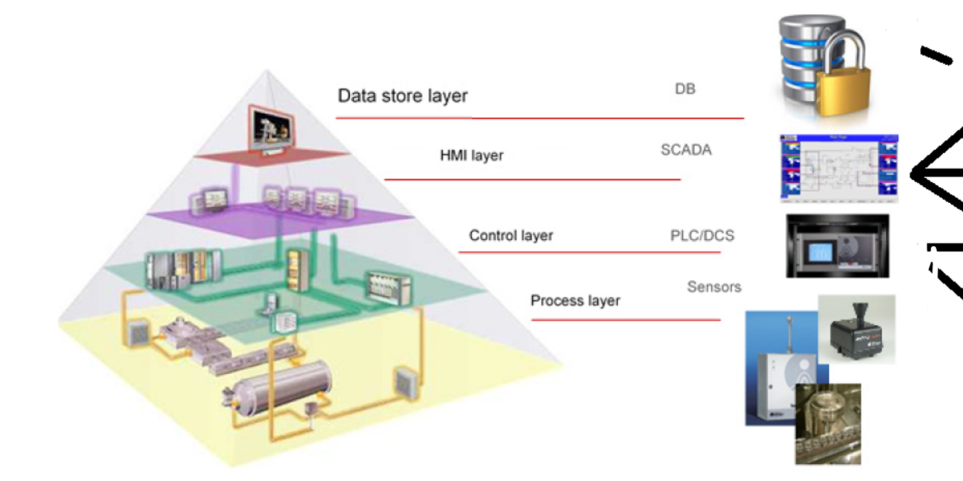

**Process Layer**  
The process layer (seen from Figure 1) is the lowest layer in the architecture hierarchy and is responsible for directly interfacing with the physical industrial processes. This layer includes sensors, actuators, motors, and other devices that collect data from the physical processes and perform physical actions. The data collected by the sensors is then sent to the control layer for processing.

**Control Layer**  
The control layer (seen from Figure 1) is responsible for processing the data received from the process layer and making decisions based on that data. This layer includes Programmable Logic Controllers (PLCs) or Distributed Control Systems (DCS) that can perform logic and control functions. The control layer communicates with the process layer to collect data and send commands to the actuators to adjust and control the physical processes.

**HMI/SCADA Layer**   
The HMI layer (seen from Figure 1) provides a graphical interface for operators to monitor and control the industrial processes being executed at the control layer. This layer includes a Human Machine Interface (HMI) or Supervisory Control and Data Acquisition (SCADA) system that provides operators with real-time data about the industrial processes, as well as the ability to adjust the settings of the control layer in real-time. The HMI layer also provides alerts and notifications to operators if the industrial process deviates from its normal operating parameters.

**Data Store Layer**  
The data store layer (seen from Figure 1) is responsible for storing historical data and other information about the industrial processes. This layer includes a database (DB) or other data storage system that stores data collected by the sensors and the control system, as well as configuration settings for the control system. The data can be used for analysis and optimization of the industrial processes, as well as for regulatory compliance reporting.

In summary, the industrial automation architecture hierarchy comprises multiple layers of components that work together to automate industrial processes. The process layer is responsible for interfacing with the physical processes, while the control layer processes the data and makes decisions based on that data. The HMI layer provides operators with a graphical interface to monitor and control the industrial processes, and the data store layer stores historical data and other information about the industrial processes.

## Goal formulation (planned solution for version 1.0)

The main goal of the thesis is to study, develop and test an industrial automation architecture using open-source software & hardware. At the end of this paper a finished working architecture will be displayed which will be used to control an example process from a web based GUI (trying to simulate a small process plant), read/write to the internet (backup, process information etc.), remote operator/engineering capability. Other things the solution should be able to do is to alter the code in operation (load new code to controller) without shutdown, simulate values both from locally at the workstation and from remote, a feature often used in real life plants where maintenance is to be performed. Should also be possible to plot data from the process. This is planned in version 1.0 to be done by reading “fresh” data from the data storage layer (database) and plot from there instead of plotting directly from the incoming data from the control layer. Given an extra delay of for example less than 100 ms, this indirect routing of data to plotting should not cause any issues.

Planned open-source software/hardware and structure for version 1 can be seen in Figure 2.

Figure 2.  
Solutions planned to use in each layer in our industrial automation architecture.

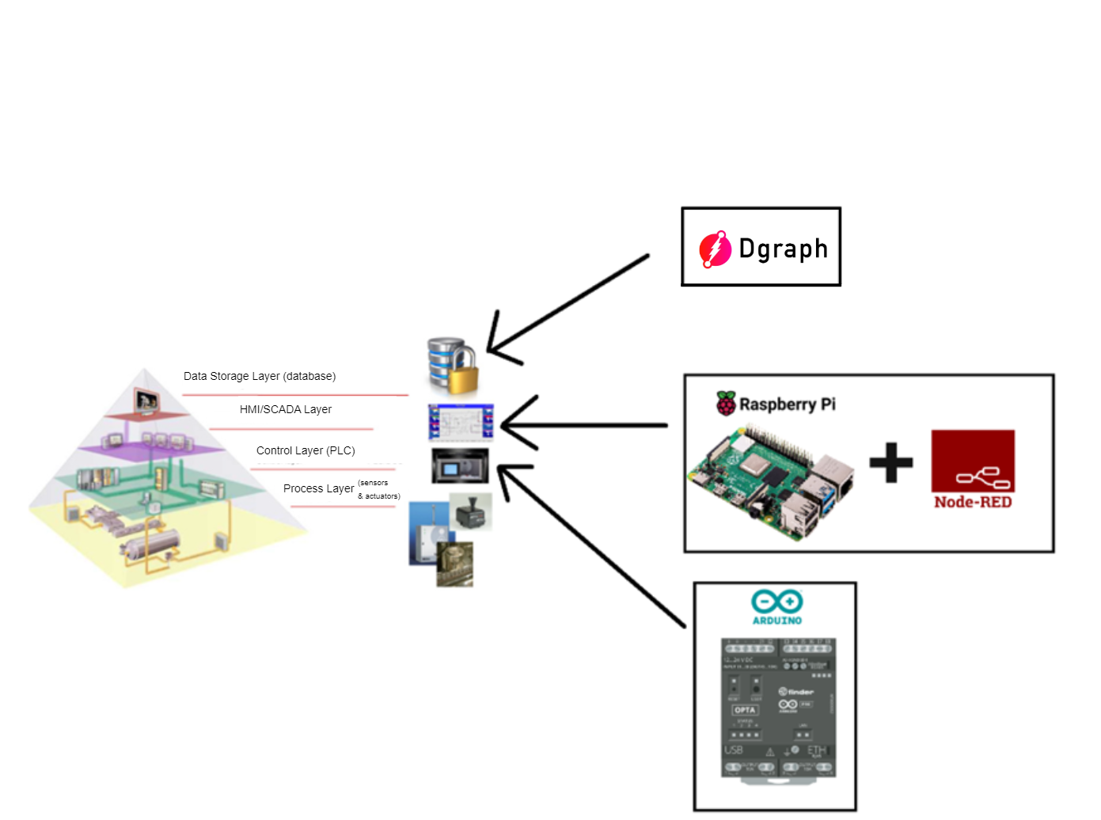

### Dgraph (planned use in Data Storage Layer (database))

Dgraph is a graph database adept at managing massive, complex data, ideal for social networks, recommendation systems, fraud detection, and industrial applications. Its native graph architecture outperforms traditional relational databases like MySQL in handling intricate relationships. Dgraph provides distributed transactions, real-time queries, and GraphQL support, ensuring faster and more reliable large-scale data processing. Its place in the industrial automation architecture can be seen in Figure 2.

### Raspberry Pi (planned use in HMI/SCADA Layer)

Raspberry Pi is an open-source hardware, small, low-cost computer that is popular for its versatility and power. It is about the size of a credit card and can be used for a wide variety of projects, such as home automation, Internet of Things (IoT) projects, media centers, and more. Being open source, it allows for easy modification and customization and there exists a large community of users that share information and improve it. The Raspberry Pi runs on a Linux-based operating system and supports various programming languages like Python, C++, and JavaScript. It has a wide range of connectivity options, including Ethernet, WiFi, Bluetooth, and USB ports. The Raspberry Pi also has a 40-pin expansion header that allows for connection to various sensors, actuators, and other devices. It has also found its place in space projects such as the European Space Agency's Astro Pi mission, where Raspberry Pi computers were sent to the International Space Station. Its place in the industrial automation architecture can be seen in Figure 2.

### Node-Red

Node-RED is a visual programming tool that allows users to create IoT applications quickly and easily by dragging and dropping pre-built nodes. It was developed by IBM and was first released in 2013 as an open-source project and in 2016, IBM contributed Node-RED as an open source OpenJS Foundation project. Node-RED is built on Node.js, a JavaScript runtime and allows for easy integration with other services like databases, APIs, and cloud services. It allows users to easily connect various devices and services together to create powerful automations, without the need for writing any code. Node-RED is pre-installed in the Raspbian operating system, the default Linux OS for Raspberry Pi. This makes it easy to use Node-RED with a Raspberry Pi and allows for the creation of various IoT projects such as home automation, sensor logging and control, and other small-scale applications. It's an open-source tool, widely adopted in the maker and IoT communities and constantly updated with new features. Its place in the industrial automation architecture can be seen in Figure 2.

### Arduino

Arduino is an open-source electronics platform that is popular for its simplicity and ease of use. It is based on microcontroller boards that can be programmed using a variety of programming languages such as its own Arduino language, a very close derivation of the C++ language, and it is commonly used in DIY electronics projects and prototyping. The boards include input/output (I/O) pins that can be used to connect sensors, actuators, and other electronic devices. Arduino boards can be easily connected to the internet via Ethernet or WiFi, making it a popular choice for Internet of Things (IoT) projects.

The Arduino platform is open-source both in hardware and software, meaning the design and schematics of the board are publicly available, and it also provides open-source software libraries and development tools that can be used to interact with the Arduino products. The Arduino IDE allows users to write, upload and debug code on the Arduino boards and is based on the Processing programming language, which is based on C++, and provides a simplified version of the C++ programming language. The Arduino PLC IDE is another software development environment which is designed for industrial control systems, It supports the IEC 61131-3 standard languages.

The Raspberry Pi and Arduino can communicate with each other using a variety of methods such as serial communication, I2C, and SPI. This allows the Raspberry Pi to act as a host and control the Arduino, or for the Arduino to send sensor data to the Raspberry Pi for processing and control. Its place in the industrial automation architecture can be seen in Figure 2.

#### Arduino OPTA

The Arduino Opta® is a micro PLC with Industrial IoT capabilities, designed in partnership with Finder®, a leading industrial and building automation device manufacturer. It offers real-time control, monitoring, and predictive maintenance applications thanks to its computing power. The Opta® can be quickly put to work and leverages the many available software libraries, making it easy to scale up automation projects. It is available in three variants and allows for network connectivity through USB, Ethernet, Wi-Fi®, Bluetooth® Low Energy, and industry-specific protocols such as RS-485. The Opta® has a highly reliable design operating at industrial temperature ranges and supports various programming languages such as C++ (standard Arduino IDE), Ladder Diagram (LD), Function Block Diagram (FBD), Sequential Function Chart (SFC), Structured Text (ST), and Instruction List (IL).

For Iteration 1.0, UNO was chosen as a replacement for the Arduino OPTA as this project aims to simulate a small process plant rather than control a real one, it is not necessary to use a real PLC. There are alternative Arduino-based PLCs available, such as the M-Duino PLC from Industrial Shield, that meet industrial standards. However, these third-party options are often very expensive. The Opta, which will be sold directly from the Arduino store, has a price tag of just over 100€, making it a more affordable option that can compete with the cheapest PLCs from mainstream proprietary manufacturers.

### Requirements

* The solution must be able to provide process operators with an interactive GUI which shows real time values without having lag and give them access to control the process.
* The solution must be able to plot data.
* The solution must be able to be remotely controlled.
* The solution must be able to send data to a database and possible other servers.
* The solution must be able to both be an option for small automation projects as well as being able to be scaled up for use in larger projects.
* The solution must be able to rely on open source hardware & software.
* The solution must be able to control an imaginary small process.
* The solution must be able to be updated by automation engineers without shutdown (control code etc.)
* The solution must enable the option of simulating imaginary values to transmitters for testing.

The solution architecture must basically be able to provide the functionality commonly needed/found in classic industrial automation architecture without relying on proprietary hardware/software.

## Hardware in stock

Figure 3.  
Hardware used in the development of our industrial automation architecture

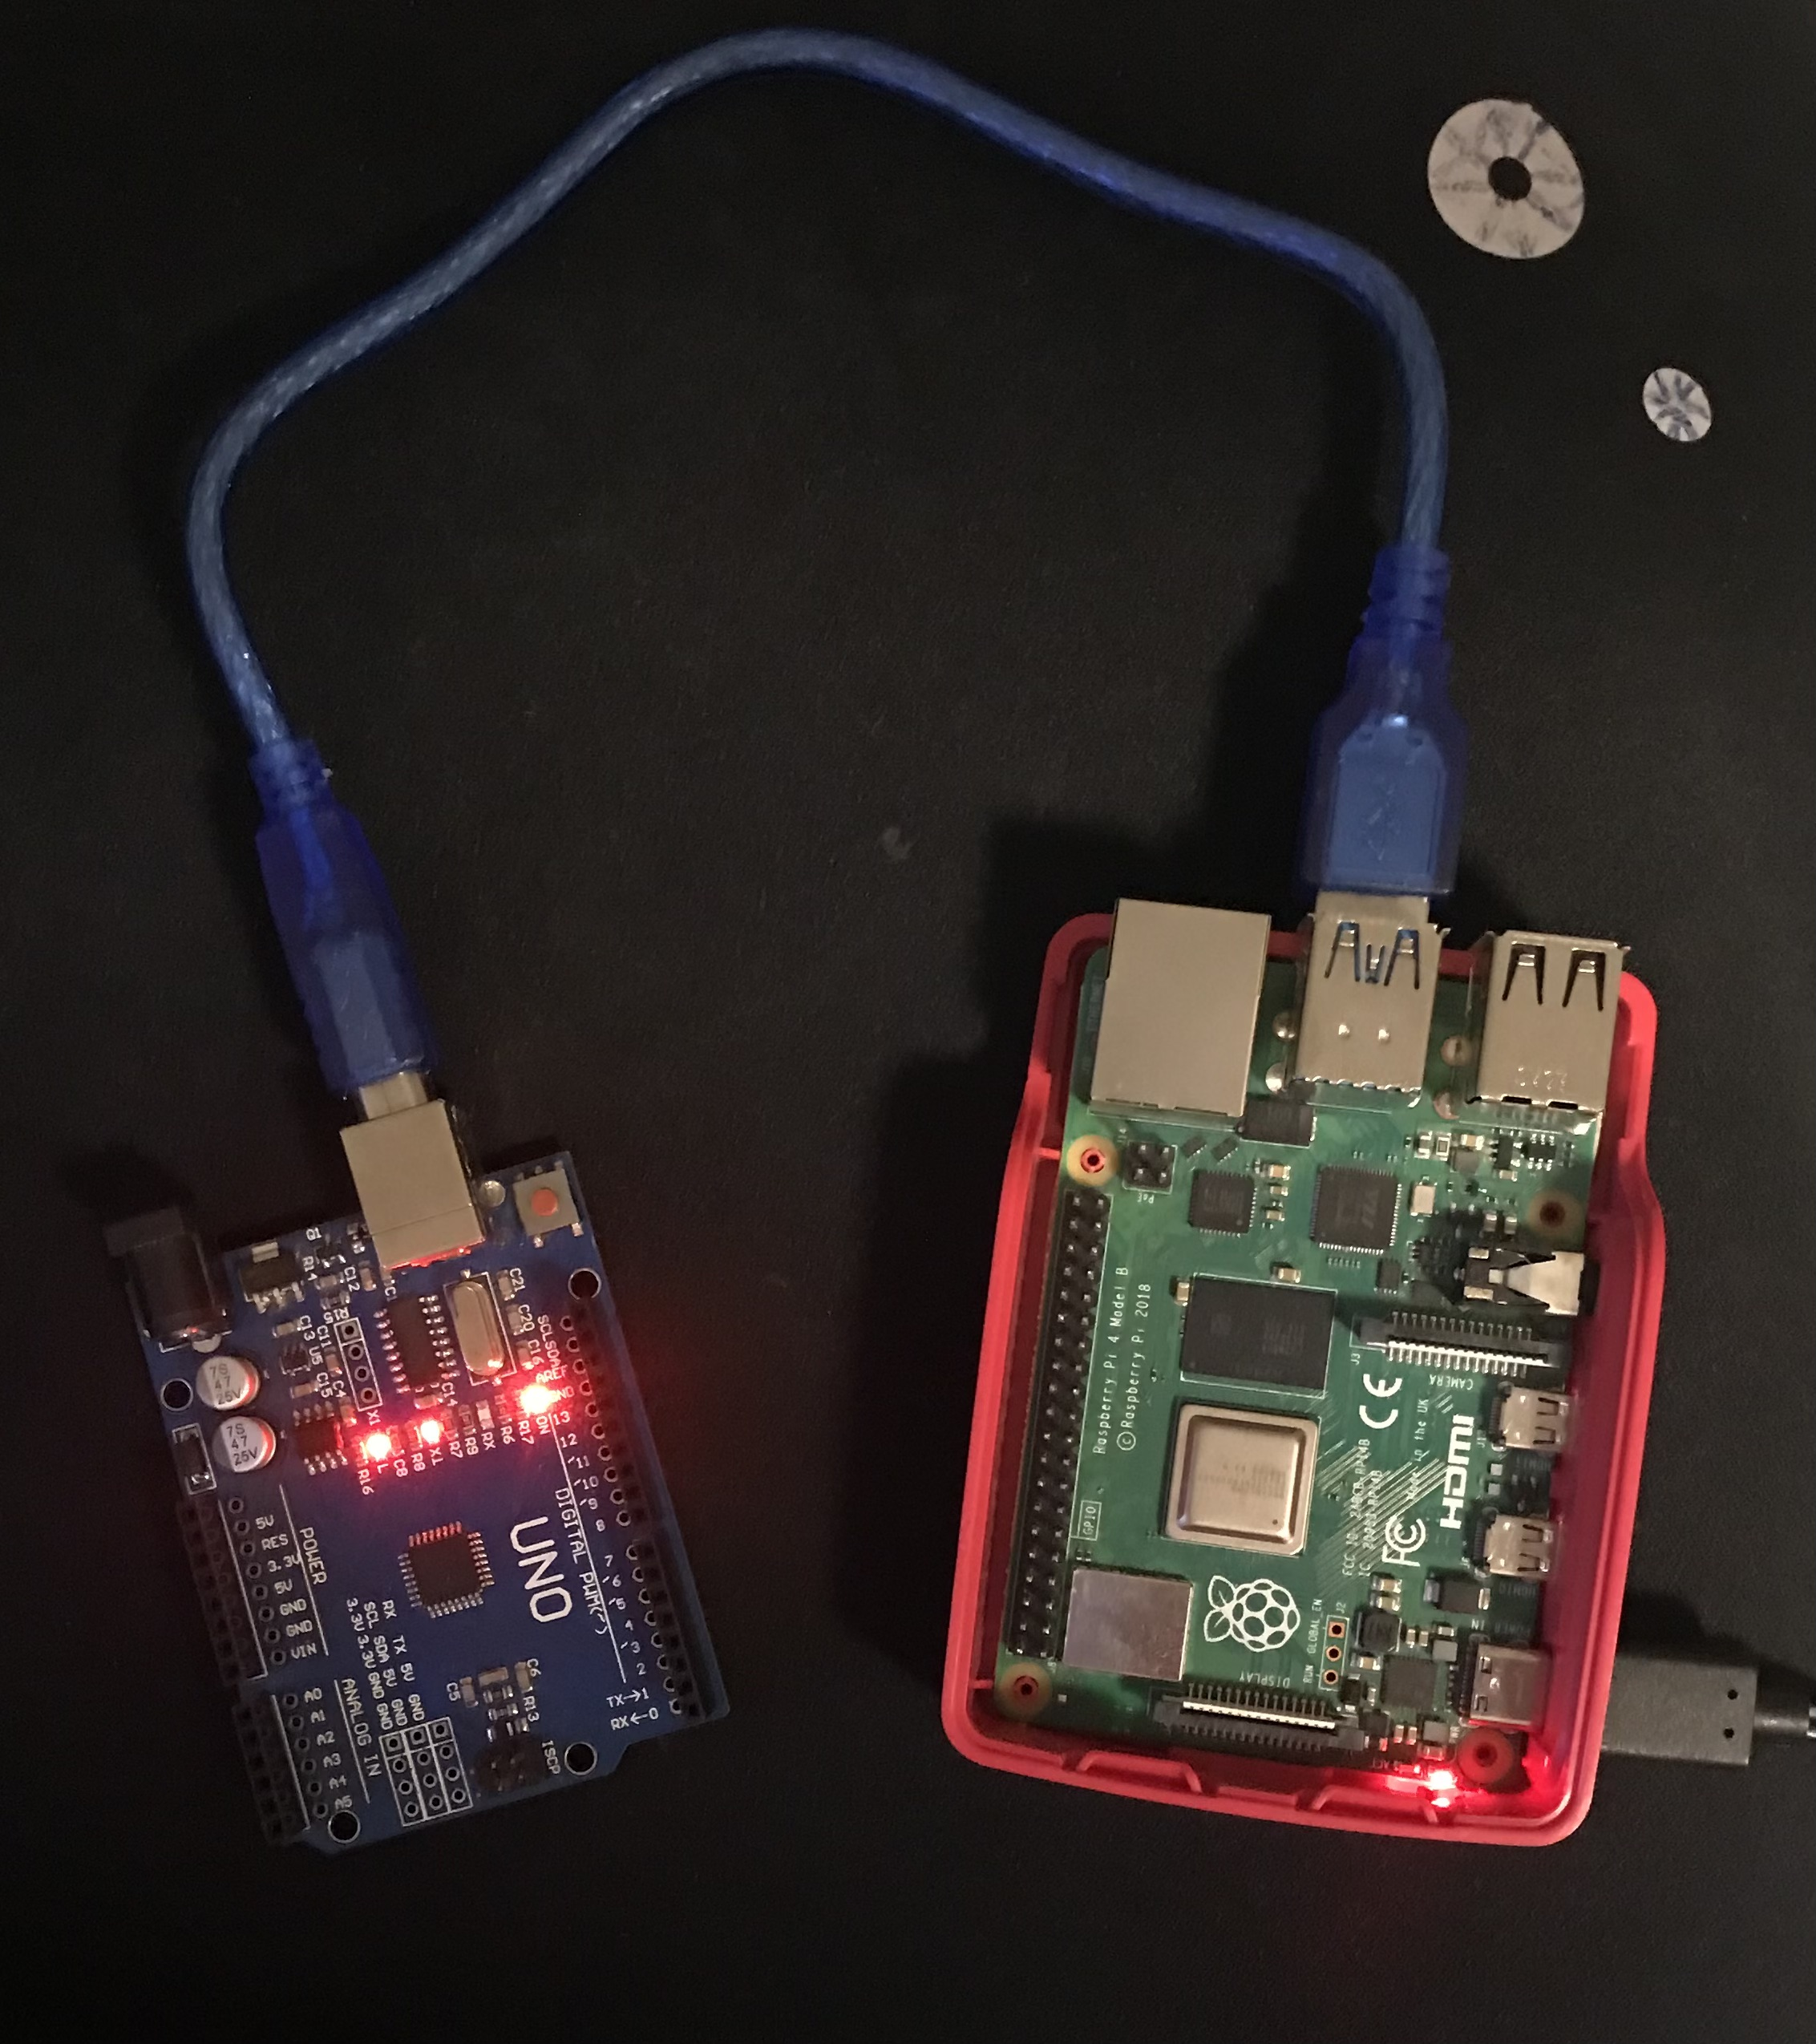

Note. Depictured is an Arduino UNO board with 2048 bytes SRAM serial connected with USB with a Raspberry Pi 4 1GB RAM running Raspberry Pi OS (32-bit) released 03.05.2023

## Project plan for thesis deadlines

Figure 4.  
Gantt diagram of project

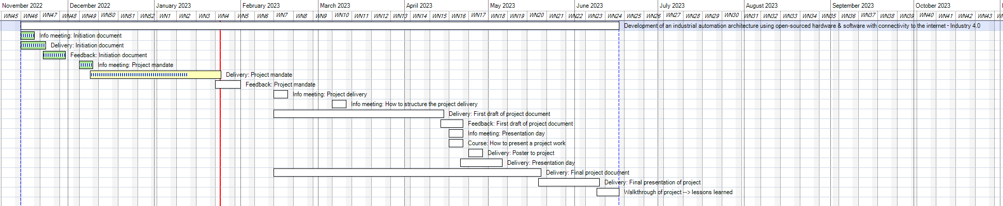  
Note. Gantt diagram made using MindManager.

Figure 5.  
Activity description in MindManager

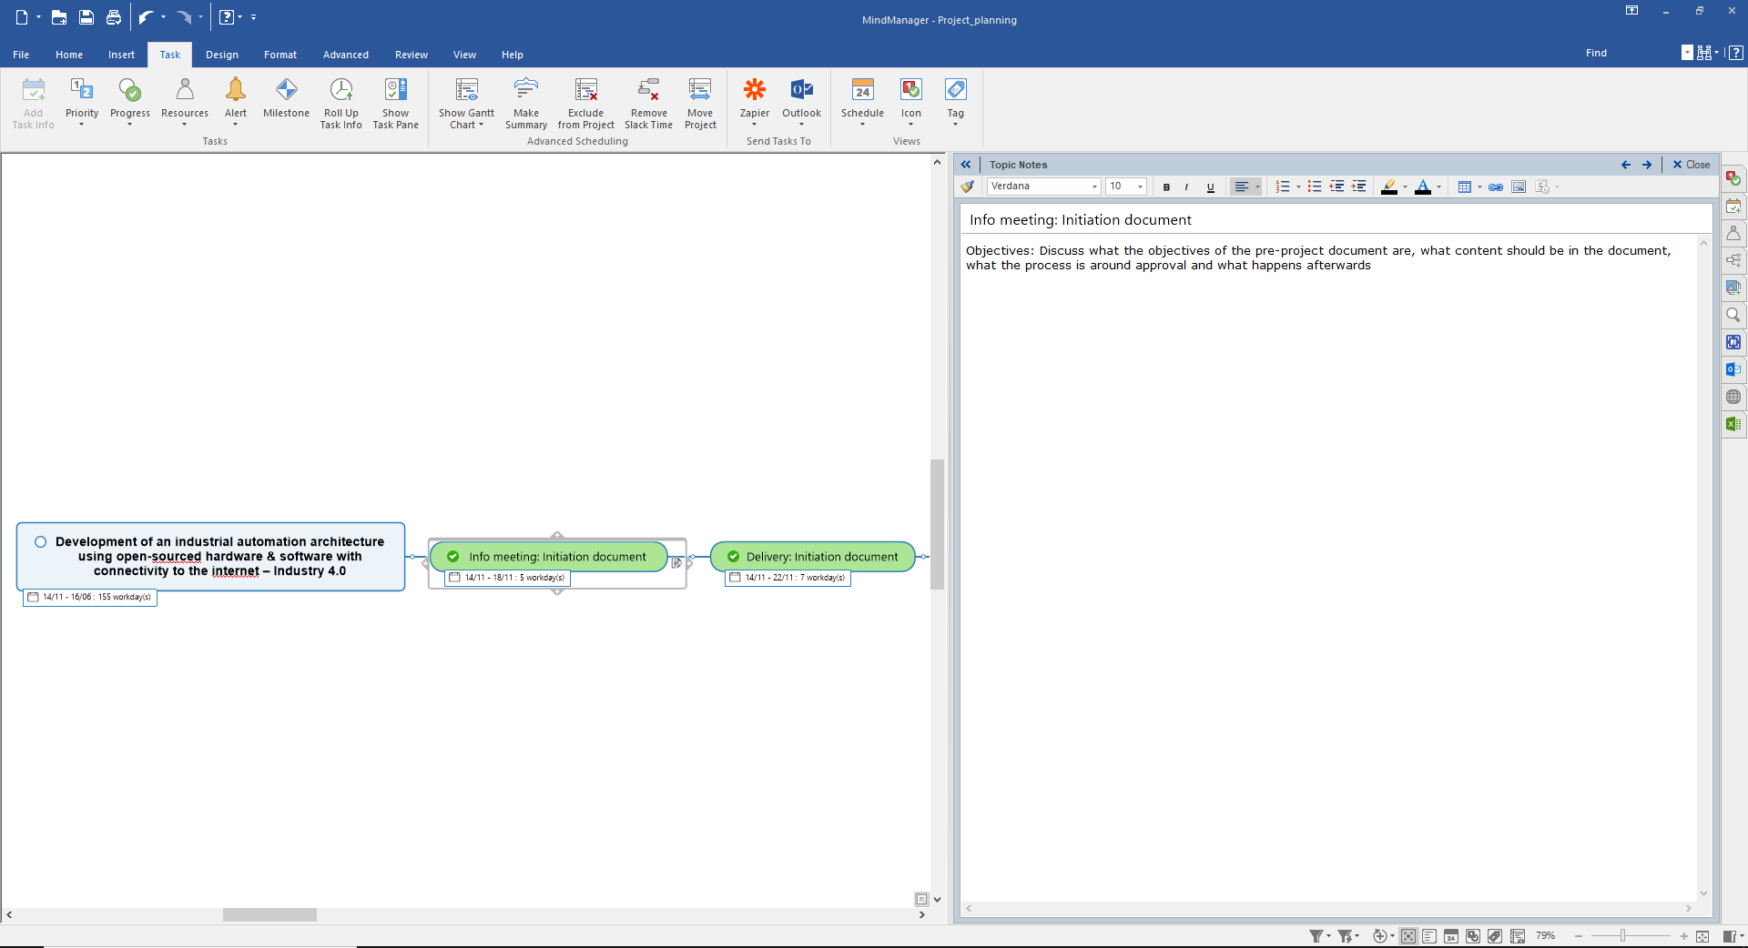  
Note. The activity description with comments/log is locally stored inside the MindManager file.

# Methodology

* Literature review: An extensive review of the existing industrial automation architecture will be performed to identify the key features and functionality of classic industrial automation systems.
* Experimentation: Different applications will be experimented with to determine their potential for providing the functionality found in classic industrial automation systems. These applications will be evaluated based on their ability to perform key industrial automation tasks, such as data acquisition, control, and monitoring.
* Implementation: The applications that will be found to be most suitable will be integrated into a single system and connected to physical hardware. The system will so be tested using simulation data to mimic real-life industrial processes.
* Validation: The system will so try to be tested/validated by comparing the results obtained from the simulation data with those expected from a real-life industrial process. The project will be successful if the system is able to perform all the functions of a classic industrial automation system and met the requirements which are found in a section further below.

# Literature review

Research question “To what extent can open-source software and hardware be used to develop a fully integrated industrial automation architecture?”.

In this section we will investigate what does exists on this topic as of spring 2023. We will visit multiple projects that have different levels of similarities and look further at these similarities but also what is different from what we are trying to achieve.

To investigate this, we will heavily use GitHub. GitHub is a web-based platform where developers can host, share, and collaborate on software development projects. It offers features such as version control, issue tracking, and code review tools, making it a popular choice for open-source projects and organizations. A perfect place to look for similar projects.

The first search words search for at Github was “industrial automation”, this search gave us the following interesting projects:

1. OpenPLC

OpenPLC is an open-source Programmable Logic Controller (PLC) platform that allows users to control and monitor industrial automation processes. It is a software-based system that runs on different hardware platforms and supports the IEC 61131-3 standard languages for programming PLCs. OpenPLC is designed to run on various PLCs, including those made by ABB, Siemens, Mitsubishi, and many others. The software is flexible enough to work with a wide range of hardware, making it a popular choice for those looking to implement open-source automation solutions. OpenPLC allows users to program and simulate PLC logic using a graphical user interface (GUI), and it can be easily connected to different types of input/output (I/O) devices such as sensors and actuators. The platform also includes a web-based human-machine interface (HMI) that enables users to interact with the PLC and monitor real-time process data. OpenPLC is a flexible and cost-effective solution for industrial automation, and it is particularly suitable for small and medium-sized applications. The open-source nature of the project allows users to modify and improve the software and hardware components to meet their specific needs.

* 1. Similarities
* Both projects aim to provide an open-source solution for industrial automation.
* Both projects support the use of various communication protocols such as Modbus, EtherNet/IP, and Profinet to enable communication between devices in the automation system.
* Both projects aim to provide a cost-effective solution for small to medium-sized industrial automation projects.
* Both projects allow for customization and flexibility in the design and implementation of the automation system.
* Both projects can be used to integrate sensors and actuators with a control system and can be used for real-time monitoring and control of industrial processes.
  1. Dissimilarities
* OpenPLC is primarily focused on providing an open-source software platform for programming and controlling industrial PLCs, not providing as much support for the HMI, data storage, and communication layers, which are also critical components of a complete industrial automation architecture. While our project focusses rather on developing a fully integrated industrial automation architecture (see Figure 1) of open-sourced software and hardware.
* OpenPLC primarily focuses on controlling industrial processes using traditional PLC programming languages like Ladder Logic, Function Block Diagram (FBD), and Structured Text (ST) (languages specified by IEC 61131-3), while our project uses Node-RED for interface programming and relies on Arduino OPTA supported languages to control the industrial process. OPTA supports the standard Arduino integrated development environment (IDE) which uses the Arduino language derived from C++, but also the newly released (as of spring 2023) PLC IDE that Arduino has developed which supports IEC 61131-3 languages. Our initial project will utilize the standard Arduino IDE, but an integration/switch to the PLC IDE should be relatively straightforward for those interested.
* After conducting searches using different keywords such as “Node-RED industrial”, “industrial automation architecture”, “Arduino automation industrial”, and “Raspberry Pi industrial automation”, we did not find any projects that closely resembled our project. The results were mostly software projects that focused on enabling the use of industrial proprietary PLCs and had more commonality to OpenPLC. However, we did find several software projects that aimed to translate different industrial protocols, which could be useful for our project. One such project is Neuron, an open-source industrial IoT connectivity server that supports multiple protocols and converts them into MQTT for interconnecting with industrial internet of things (IIOT) platforms. Although it is not closely related to our project, it is still an interesting project.

# Iteration 1.0 (v1.0 & i1.0) of solution

As seen from Figure 2 we really have three layers that this thesis will focus on. These are the Control layer, HMI layer and the Data Storage Layer. The process layer won’t be of primary focus, and it is planned to simulate an example process to test our system which will be hosted in Node-RED.

## Control Layer (Arduino)

### Overview

In the control layer, which is hosted by our microcontroller Arduino UNO, our goal is to first establish connection between Arduino and Raspberry Pi. From the Raspberry Pi we can upload logic through the Arduino IDE to the UNO board. When this is complete, we are to create the control logic to control the imaginary process planned. This control logic is a sequence/state-machine logic that is to run when the operators set the control layer mode to auto. The control layer must also include logic that both enable operators to run the process manually as well as being able to freeze/simulate sensor values as well as force actuator values. More in detail about how and why we do this later throughout these sections. Control layer is also the first interface to the process layer and therefore will also need to handle the formatting part that enable us to structure the raw sensor/actuator data in a format that we are able to interact with the process data as well as communicate the data to the next layer, the HMI layer.

### Imaginary process – Batch-process

We have chosen a batch-process as our imaginary process (displayed in Figure 6), which is described in an introduction to industrial automation book used at the University of Tromsø. The book, authored by Hanssen (2015), provides graphics, descriptions, and flow/state-diagrams of the process on pages 126-133. The figures listed below are found in these pages.

Figure 6.  
Batch imaginary process with sensors and actuators

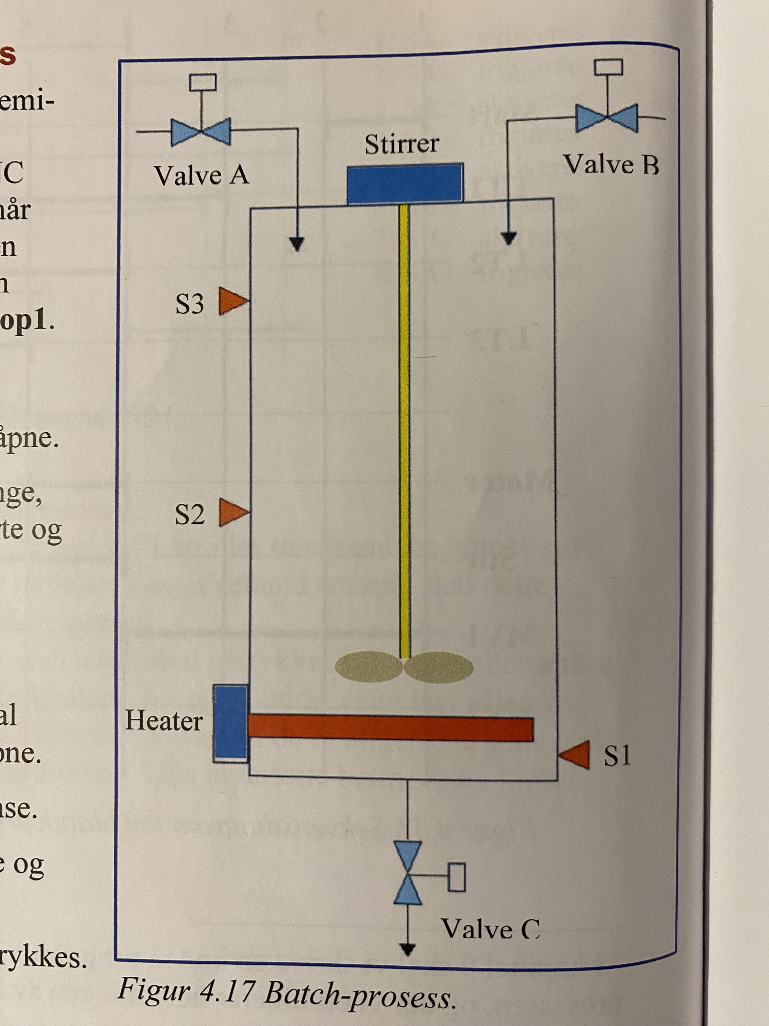

Note. Figure adapted from figure 4.17 in Hanssen's (2015) book, Programmerbare logiske styringerbasert på CoDeSys, en praktisk tilnærming til standarden IEC 61131-3.

The system is designed to work as follows (graphically displayed in Figure 7 & Figure 8):

* Upon receiving the start signal, valve A should open.
* When level S2 is reached, valve A should close, the heating element and agitator should start, and valve B should open.
* At level S3, valve B should close.
* When the temperature reaches 85°C, a timer should be activated. Thirty seconds later, heating should stop, and valve C should open.
* The agitator should stop below level S2.
* Valve C should close below level S1, and valve A should open again.
* The sequence is repeated until Stop1 is pressed.

The sequence diagram seen in Figure 7 is based on the following assumptions/ considerations/choices:

* Assumes that the tank is empty at startup. Note that the level switches are of the NC type, i.e., they emit a logically high signal when they are not activated.
* A time delay must be activated when the desired temperature is reached (Temp_Ok). After 30 seconds, the output of the time delay, Timer.Q, goes high. (Note the timing between action line 6 and 7.)
* The system completes an ongoing sequence before stopping if Stop1 is pressed. In a program code, we must save the event "Stop1 pressed" and check it at the end of the ongoing sequence. However, it is not useful to draw alternative outcomes in a sequence diagram, so stopping cannot be illustrated.
* After the heating element (Heater) is turned off, we do not know when the temperature will drop below the desired temperature again. It is assumed here that this happens after the liquid level drops below level 2 but before it drops below level 1.

Figure 7.  
Sequence diagram of the batch process seen in Figure 6.

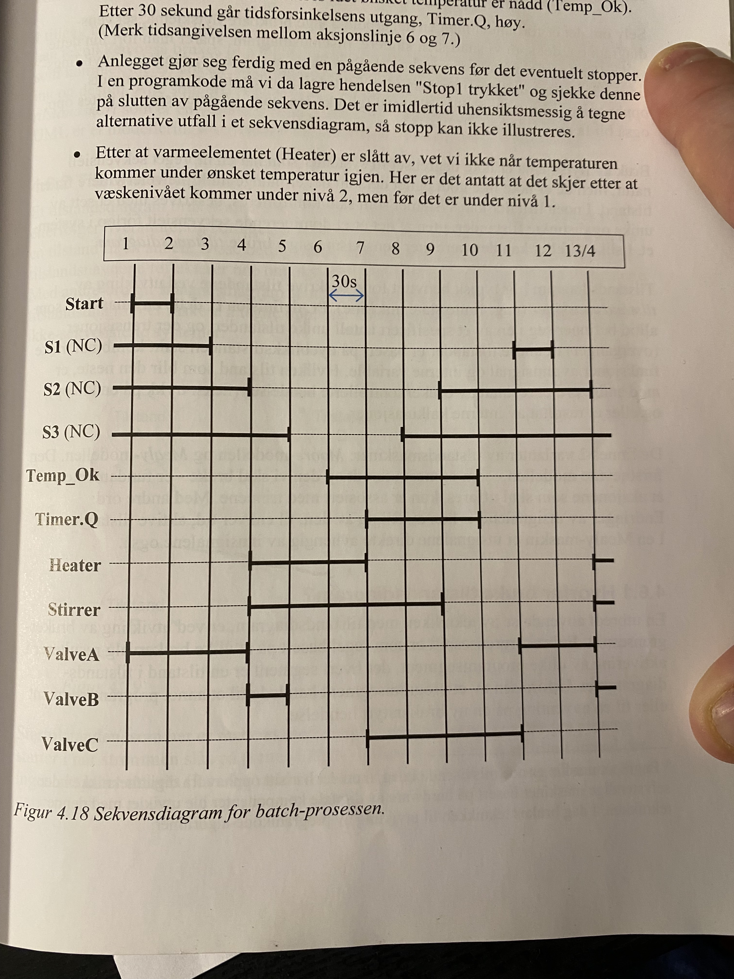

Note. Figure adapted from figure 4.18 in Hanssen's (2015) book, Programmerbare logiske styringerbasert på CoDeSys, en praktisk tilnærming til standarden IEC 61131-3.

Figure 8.  
State diagram of the batch process seen in Figure 6

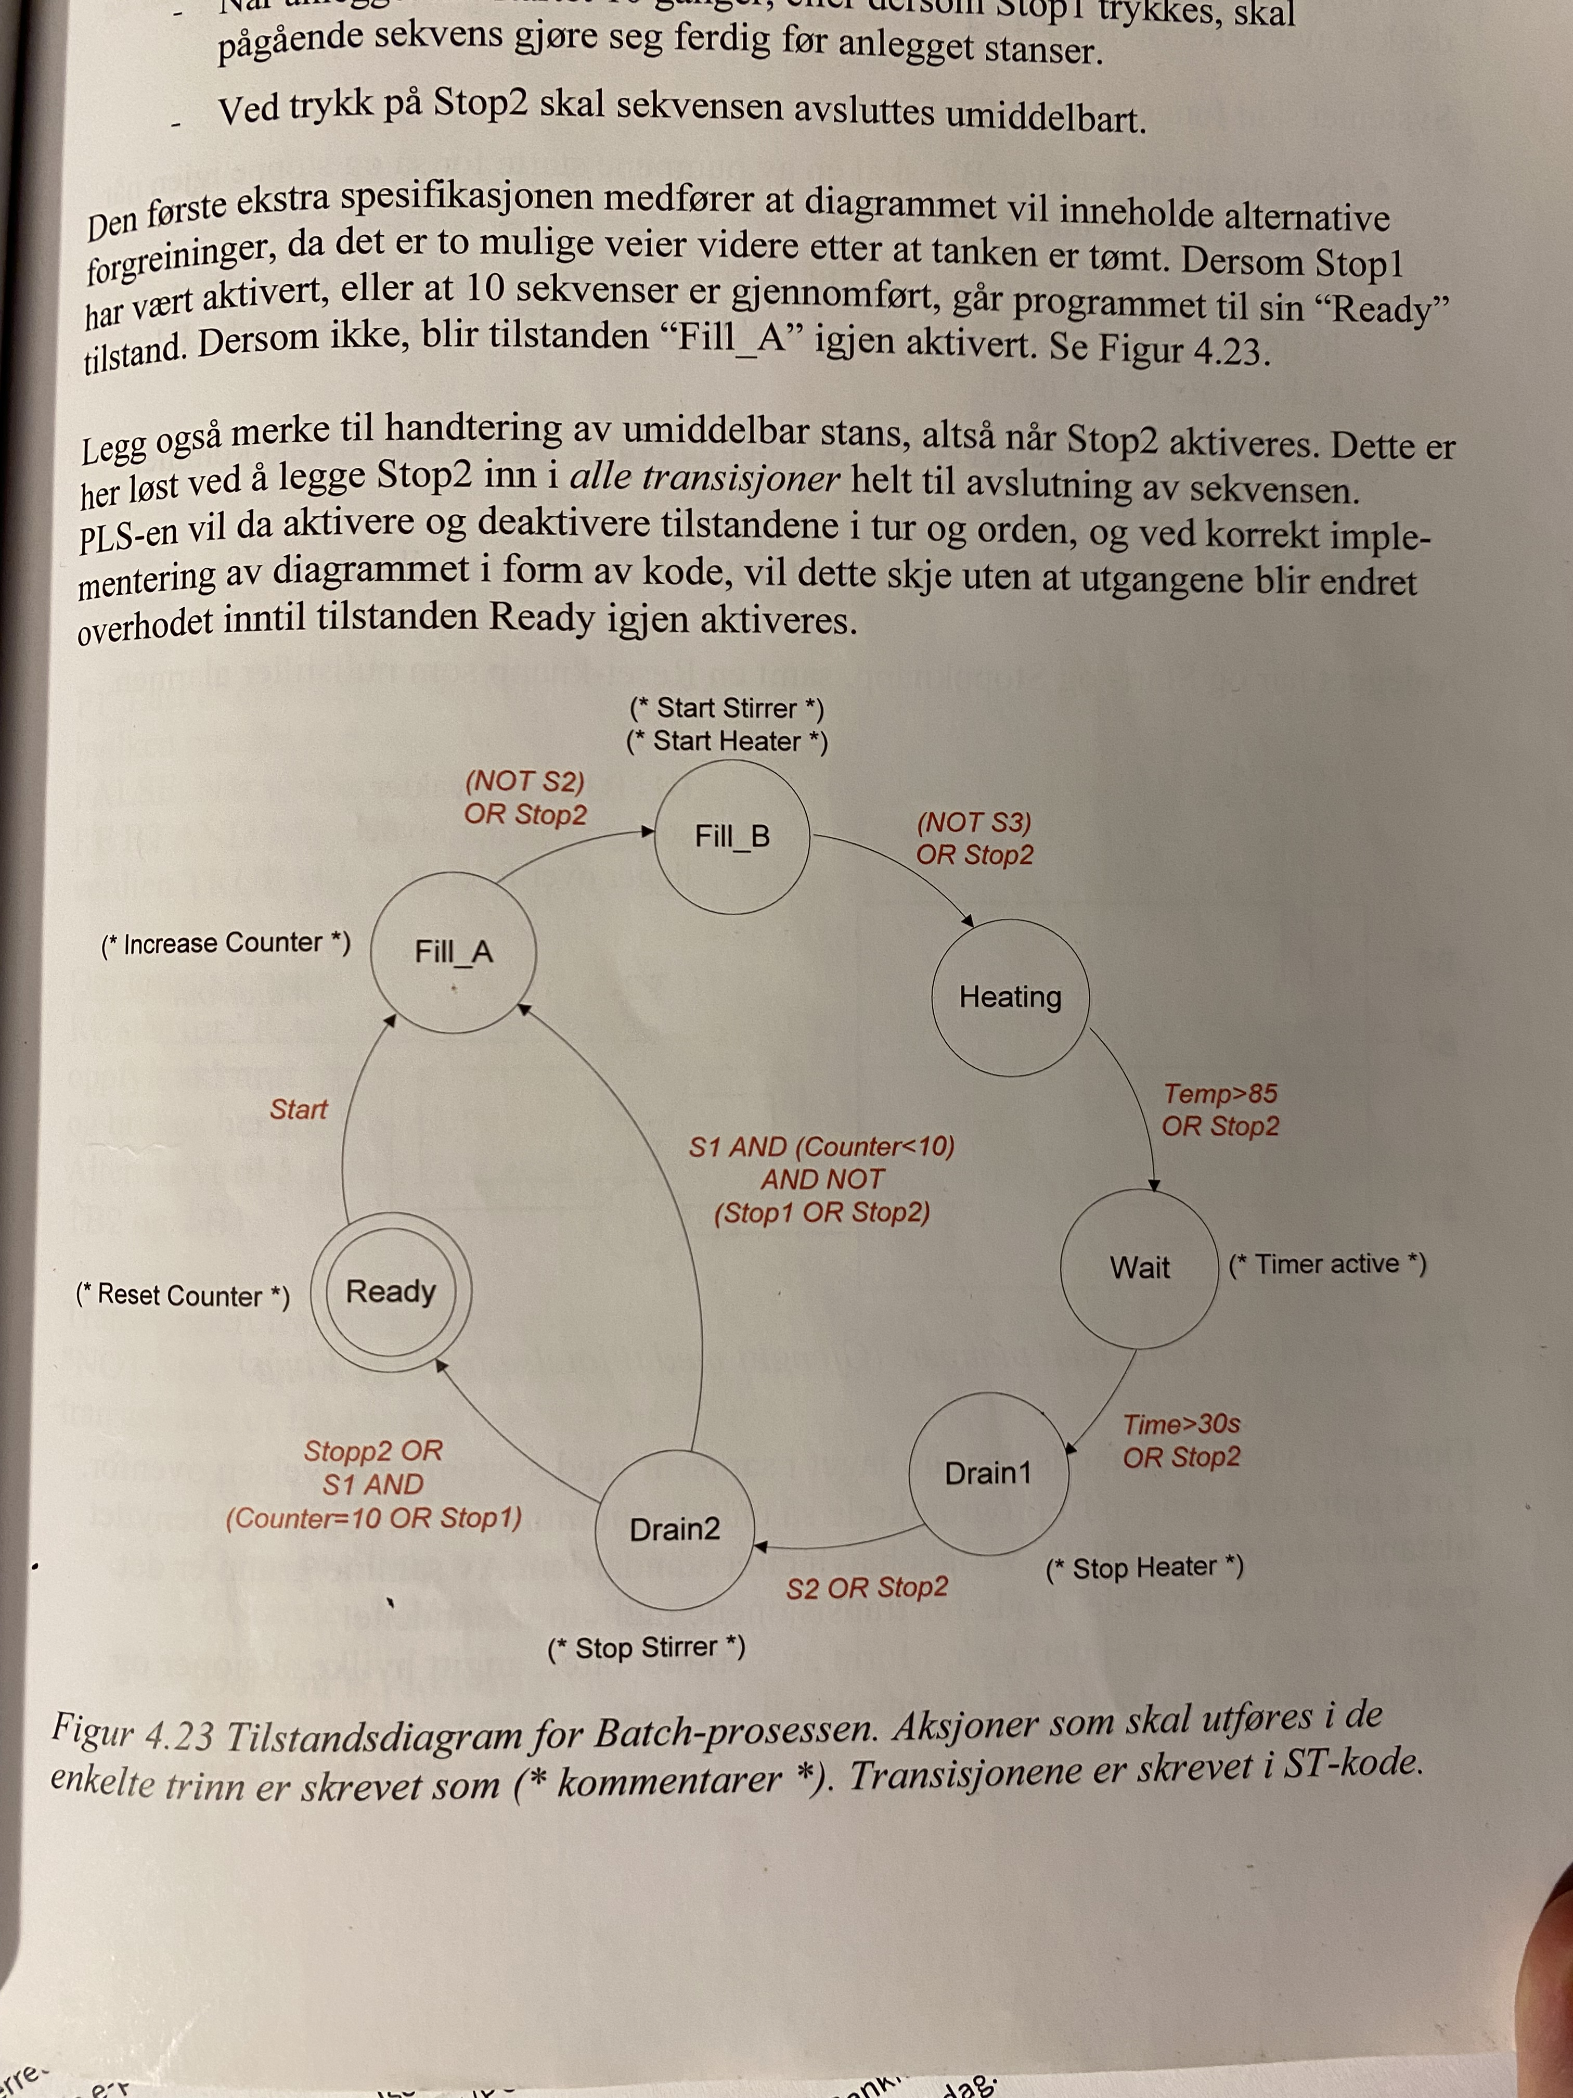

Note. Figure adapted from figure 4.19 in Hanssen's (2015) book, Programmerbare logiske styringerbasert på CoDeSys, en praktisk tilnærming til standarden IEC 61131-3.

### Choice of IDE

At the current time (spring 2023) Arduino have four different IDEs available:

1. Arduino IDE 2.0.4 (latest newest)
2. Arduino IDE 1.8.19 (legacy)
3. Arduino web IDE
4. Arduino PLC IDE 1.0

However, the Arduino IDE 2.0.4 is not officially supported on Raspberry Pi 4 running Raspberry Pi OS, so it will not be used in this thesis (iteration 1.0). The web IDE, which supports IDE version 2 features, can be used to create and modify code from any computer and upload it directly to the cloud for the Arduino board. However, this approach can be slower and still requires the use of the Raspberry Pi for uploading code. A better approach is to use VPN and VNC to access the Raspberry Pi desktop directly. This allows a master server to host a VNC viewer application, such as RealVNC, which has access to all of the plant's Raspberry Pi computers, enabling users to easily access the desired Raspberry Pi. The master server can also run programs/scripts for all remote Pis in one place, which has strong similarity to classical industrial automation architecture.

Utilizing VPN to a server with multiple security features is also believed to be more secure than hosting control software directly online with Arduino's cloud. This approach allows users to efficiently manage and update the control layer of all Raspberry Pi computers in the plant from a single, secure location. It is important to note that code cannot be uploaded to an Arduino board connected to a Raspberry Pi directly from the web-based Arduino IDE on a PC. Instead, the code must be uploaded from the Raspberry Pi itself, making VPN/local-access a necessity anyway. While Arduino's cloud enables full control of code editing for all controllers hosted on the cloud, making editing different controller codes very easy and accessible, it also increases the security risk. Therefore, having only one access point such as a master server connected to the internet and accessing the LAN using a VPN through the master server is believed to be a more secure option. Control Layer code is "hidden" by each Raspberry for the controllers it is connected to, adding an extra layer of security.

Using C++ in the standard IDE provides high-level code with many functionalities compared to more low-level code used in PLCs, making it possible to compact the code much more and perform both formatting, communication, and process logic in one sketch very easily. The standard IDE with C++ also has a huge number of prewritten libraries for us to use. Authors personal preferences make us therefore avoid PLC languages and therefore the Arduino PLC IDE 1.0 are also not a viable option.  
  
This leaves us with Arduino IDE 1.8.19, the chosen Arduino IDE for this project’s version 1.0.

### Objective of the Control Layer Logic

#### Program execution design

Before writing any code, it's crucial to consider what it should accomplish. Our primary objective is to develop control logic to manage the hypothetical process depicted in Figure 7. However, we also need the code to communicate with Node-RED hosted on the Raspberry Pi. This requires us to send and receive formatted data to and from Node-RED. Specifically, we will transmit process value and control variable values from our control layer to our HMI layer, which means from the Arduino to the Raspberry Pi (see Figure 3). This will make process and logic data readable for the operators and enable the HMI layer to make the control layer data available for the data storage layer (see Figure 3). Additionally, we need to be able to receive data, allowing operators to write from their HMI layer to the control layer, for example force activating an actuator.

In practical use cases, the Arduino will be connected to multiple sensors and actuators, reading, and writing values from/to the process layer directly itself (see Figure 2). Therefore, our HMI layer won't receive any data unless we pass the data on to it (again referring to Figure 2). If there is no data for the HMI layer, the operator won't be able to view or control the process, leaving the control layer to manage the process independently. This is not desirable, as we always want an operator to oversee the process and logic, ensuring that everything runs smoothly during normal operation. Moreover, during maintenance situations, the operator is required to manually control the process and freeze/simulate binary/decimal values from sensors that are currently down (zero output) for maintenance as well as being able to force on/off actuators. To be able to have these features with control logic (our process case controlling state-machine/sequence) and read/write ability in series.

• Logic loop executing the state logic sequence seen in Figure 8 and Figure 9. (Illustrated graphically in Figure 9).

• Intermediate Loop which handles the communication and formatting of data between Control layer and the HMI and Process Layer. Also have some error checks which it sends to the HMI layer to be displayed on the GUI. (Illustrated graphically in Figure 9).

For PLCs the common setup of every scan cycle consists of:

1. Input Scan: The PLC reads the current state of all input devices (e.g., sensors, switches) and stores this information in its memory. This step ensures that the PLC has up-to-date input data when processing the control logic in the next step.
2. Program Scan: The PLC processes the control logic. This logic can include state machines, sequence logic, and other decision-making functions. The control logic is designed to be executed quickly and efficiently so that the PLC can make decisions based on the most recent input data and move on to the next step. Written in non-blocking instructions.
3. Output Scan: The PLC updates the state of all output devices (e.g., actuators, valves) based on the decisions made during the program scan. This ensures that the outputs are always up-to-date, reflecting the current state of the system.
4. Housekeeping: The PLC performs any necessary diagnostics, communication tasks, or other housekeeping activities before starting the next scan cycle.

Our setup shares many common things with the common PLC setup but instead of separating the control logic from formatting and communication code our setup have them in a complete Arduino sketch where the control logic loop, executing control logic, is run every loop of the intermediate loop, which handles everything else from formatting of data, communication as well as some error checks.

#### Practical execution in our control layer with Arduino and formatting of data between the layers

The control logic for our process is relatively straightforward and was created directly from Figure 8 and Figure 9 as a state machine, which runs a sequence and moves on given certain conditions. This approach is similar to one of the five languages stated in the IEC 61131-3 standard called Sequential Function Chart (SFC) used in classical PLC automation. Each "box" in the SFC is filled with another IEC 61131-3 language, Structured Text (ST), which is the only text-based language found in the industrial PLC standard. We use “Arduino C++” (Arduino’s version of C++) to perform everything. The "case" instruction (a large if statement) has logic in each state, and inside each case, we actuate the actuators specified and check if the transition condition for the next state is met. If it is not, we break out of the logic loop (see Figure 9) and proceed with the intermediate loop, formatting, communicating, and checking for errors.

To transmit data between the Arduino IDE and Node-RED applications, we need to format the data in a suitable way. The available options include JSON (JavaScript Object Notation), CSV (Comma-Separated Values), or plain unformatted text using the "serial.print" method. For iteration 1.0, we use plain serial communication with USB, as a real process layer does not exist, and there is no need to add a more complex communication protocol. JSON is the most suitable format for our project because it is easily human-readable (easy for debugging), has a flexible data structure, is a lightweight format requiring low bandwidth, and has wide support in the software world, including Node-RED (which is based on JavaScript and uses JSON as its native data format). For the Arduino, we use the popular ArduinoJSON library, which supports JSON to be easily used on the Arduino platform.

**Figure 9.  
A graphical overview of how the Control Layer is to be set up and how it is connected to the Process Layer and HMI Layer (see Figure 2 for full hierarchy)**

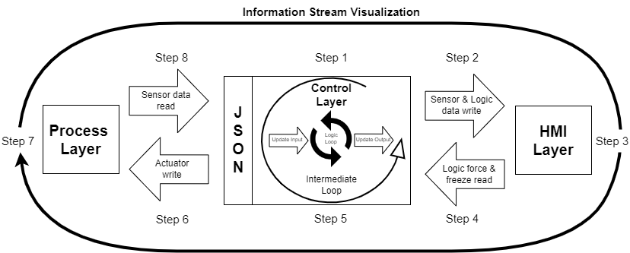  
Note. The figure is made in Draw.io, an open-sourced diagramming software.

Figure 9 illustrates the path of data beginning from the Process Layer, where it is initially read into the Control Layer. The data is then written into the HMI Layer, read back into the Control Layer, and finally written back to the Process Layer, completing the loop that is drawn around the figure. The diagram provides a visual representation of the flow of data throughout the system, illustrating how information moves between the different layers of the system.

### Implementation of code in the Control Layer

#### Overview

Below is an explanation of the Control Layer sketch (Arduino code) that handles all steps (except 3 and 4, which is hosted in Node-RED). Code can be found in GitHub repository, see guidelines in Appendix B.

This document provides a comprehensive overview of an Arduino-based process control system designed to mix and heat two chemicals, A and B, in a tank before draining the resulting mixture. The system uses a state machine to handle different stages of the process and relies on sensor data to manage transitions between states. The system also communicates with a Human-Machine Interface (HMI) using JSON data via serial communication.

**System Components:**

* Libraries and Global Variables: The Arduino sketch starts with the inclusion of necessary libraries and the definition of global variables for sensor readings, input/output variables, states, and time-tracking.
* Setup Function: The setup() function initializes serial communication at 38400 bps (bits per second) and waits for 10 seconds to ensure that the serial communication is up and running before starting the main program loop.

**Main Loop Function:**

The main loop() function consists of several steps that are executed in sequence. Each step is responsible for a specific task, as detailed below:

* WriteInUpdatedVariables(): This function updates the input variables based on the sensor data read in SensorDataRead().
* StateMachine(): This function contains the main control logic for the process. It executes the process logic sequence and manages the transitions between different states.
* WriteOutUpdatedVariables(): This function updates the output variables based on the changes made by the StateMachine() function.
* SensorLogicDataWrite(): This function sends data from the Control Layer (Arduino) to the HMI Layer (Node-RED) for visualization and user interaction.
* RequestLogicForceFreezeRead(true): This function sends a request to the HMI Layer (Node-RED) to receive modified data (if any) from the HMI.
* LogicForceFreezeRead(): This function receives data from the HMI Layer and updates the input variables accordingly.
* RequestLogicForceFreezeRead(false): This function stops the HMI Layer from sending data without a request from the Control Layer (Arduino).
* ActuatorWrite(): This function reads the JSON data from the HMI Layer, modifies it, and sends it back to the Control Layer.
* RequestSensorDataRead(true): This function sends a request to the Process Layer (Node-RED) to receive updated sensor data.
* SensorDataRead(): This function receives sensor data from the Process Layer, which is updated by the simulated process hosted in a Node-RED function node.
* RequestSensorDataRead(false): This function stops the Process Layer from sending data without a request from the Control Layer (Arduino).

**State Machine:**

The core logic of the process control system is managed by the StateMachine() function. It uses a switch-case statement to handle different states and transitions based on sensor readings, input variables, and conditions. The state machine has the following states:

* ready: The initial state where the system is idle and waiting for the start signal.
* fill_A: The state where valve A opens to fill the tank with chemical A.
* fill_B: The state where valve A closes, valve B opens, and the stirrer and heater start to mix and heat chemicals A and B.
* heating: The state where the heater continues to heat the mixture until the temperature reaches a specified level.
* wait: The system waits for a set period before moving to the next state.
* drain1: The heater turns off, and valve C opens to drain the mixture until the tank level drops below a medium level.
* drain2: The stirrer stops, and the system continues draining the mixture. The process restarts or stops based on specific conditions.

**Detailed State Machine Functionality:**

* ready**:**

Valve C (vC) is set to false (closed).

If the start condition is met and stop2 is false, the state transitions to fill_A, and the variable PreviouslyVisited is reset.

* fill_A:

On the first visit, the counter increments, and PreviouslyVisited is set to true.

Valve C (vC) remains closed, and valve A (vA) opens to allow chemical A to enter the tank.

The state transitions to fill_B if the medium level indicator (s2) is reached or stop2 is true, and PreviouslyVisited is reset.

* fill_B:

Valve A (vA) is closed, valve B (vB) opens, and the stirrer and heater are activated.

The state transitions to heating if the high-level indicator (s3) is reached or stop2 is true, and PreviouslyVisited is reset.

* heating:

Valve B (vB) is closed to stop the flow of chemical B.

The state transitions to wait when the temperature (temp) reaches or exceeds 85 degrees Celsius, or stop2 is true, and PreviouslyVisited is reset.

* wait:

On the first visit, the current_time variable is set to the current time (millis()), and PreviouslyVisited is set to true.

The state transitions to drain1 after 30 seconds or when stop2 is true, and PreviouslyVisited is reset.

* drain1:

The heater is deactivated, and valve C (vC) is opened to drain the mixture.

The state transitions to drain2 when the tank level is below the medium level indicator (s2) or stop2 is true. PreviouslyVisited is reset.

* drain2:

The stirrer is deactivated.

If stop2 is true and either the low-level indicator (s1) is reached, the counter equals 10, or stop1 is true, the state transitions to ready, and PreviouslyVisited is reset.

If the low-level indicator (s1) is reached, the counter is less than 10, and neither stop1 nor stop2 is true, the state transitions back to fill_A, and PreviouslyVisited is reset.

* Time Tracking:

The StateMachine() function also tracks the time spent in the current sequence (TIS) and the total run time (TR) since the sketch was uploaded. The time variables are updated and converted into seconds (TISJSON and TRJSON) for communication with the HMI.

**Conclusion:**

This document provides a detailed explanation of an Arduino-based process control system designed to mix, heat, and drain two chemicals. The system employs a state machine to manage the different stages of the process and uses sensor data to manage transitions between states. It also communicates with an HMI using JSON data via serial communication, enabling user interaction and visualization.

## HMI Layer (Node-RED)

### Overview

Our objective in the HMI Layer, as depicted in Figure 9., is to manage the JSON formatted sensor/actuator data that is transmitted to us from the Control Layer via the Process Layer. This data, which represents the raw/real/logic information generated by the sensors and the control logic of the actuators, must be made accessible to operators or engineers so that they can monitor the current status of the Process Layer/Control Layer data. To achieve this, the HMI Layer must provide a graphical user interface (GUI) that displays the data and enables them to modify it. This can include actions such as freezing a sensor value, forcing an actuator value (in manual mode), and transitioning between different states, allowing them to work with and modify the data as required. Any modifications made by the operators must be reflected in the HMI to ensure that they are aware of the data being sent to the Control Layer, which will be used by the control logic to regulate the process.

In order to create an effective HMI, it is essential to include an illustration of the actual process (similar to that depicted in Figure 6.), showing the location of each sensor/actuator. This will enable operators to visualize the layout of the system and easily locate individual sensors and actuators. By incorporating this into the HMI, we can provide a more user-friendly interface that simplifies the process of interacting with complex systems.

### Objective of the HMI Layer Logic

As previously discussed, the HMI Layer Logic is written with nodes in Node-RED (described in detail in 2.7.3). The goal of the HMI Layer Logic can be viewed in Figure 9. It must be able to read data from the Control layer, the “Sensor & Logic data write” (described in detail in the Main Loop Functions from 5.1.5.1, also known as “Step 2”). This data tells the HMI Layer what the Control Layer currently read from the Process Layer and also what the Control Layer wants to do with the situation (what actuators the Control Layer wants to actuate in response to the current sensor values). This incoming data will be displayed in the GUI, but if the operator makes a overwrite/freeze then the “real” value will no longer be displayed and the overwrite value will take its place. For iteration 2 a plan to make real values show up alongside the frozen value will be implementet so the operators also know what is currently happening in the field as well as the value they have frozen/overwritten field values / program variables too. This processing is called “Step 3” and involve the whole Node-RED logic seen in Figure 10. After potentially applying operator/engineer inputs in the GUI we send the values from “Step 2”, also known as “Sensor & Logic data write” back to the Control Layer in “Step 4”, also known as “Logic force & freeze read” which also is described in more details in the Main Loop Functions from 5.1.5.1.

Figure 10.  
Node-RED logic of the HMI Layer as well as the Process Layer

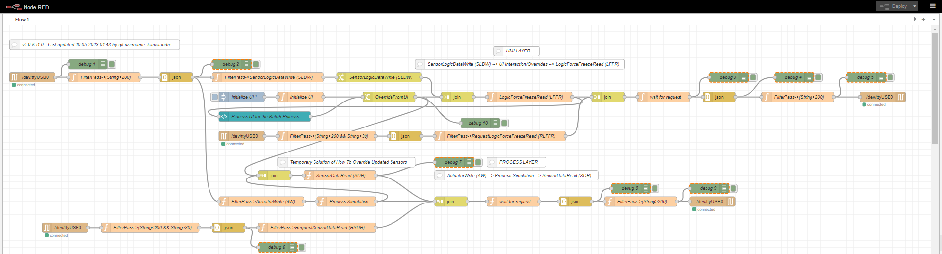

Note. To view this code, see guidelines in Appendix C and import it into Node-RED to display the code graphically in node as displayed in this figure.

### How the GUI was made

We made our GUI by using draw.io, here we are able to draw using symbols/shapes and able to make a static illustration of the GUI. We added shapes that looked like buttons, and replicated the process seen in Figure 6 as well as the state diagram seen in Figure 8. When we were happy with the figure, we exported it into SVG. SVG is often used for web development because it is a scalable vector graphics format that can be resized without losing quality. It is also lightweight, easy to animate, and can be easily embedded into HTML documents, making it ideal for creating interactive and visually engaging content on websites and other digital media. By being able to display our figure in a HTML document meant we could paste our static figure straight into a “template” node from the “node-red-dashboard” library in node-red. The “node-red-dashboard” display a “dashboard” in the “localhost:1880/ui” URL, which in turn is hosted by the Rasberry PI 4 (see Figure 3) which runs the node-red server. But this URL can be reached by any computer within the LAN and one can view the GUI from any device able to request the webpage from the Raspberry Pi inside the LAN.

When the static image is up and running and we have a “template” of how the GUI should look like we can start making it interactive by introducing JavaScript. By JavaScript we are able to create an interactive GUI with buttons that both have animation (changing color when clicked etc.) as well making them output a msg.payload within node-red which we further can use to override/interact with the Control Layer and then further on to the Process Layer (see step 4, “Logic force & freeze read” in Figure 9). The “template” node hosting our webpage is the blue node called “Process UI for the Batch-Process” seen in Figure 10. Notice how it read in its “own” data, overwriting data from the “SensorLogicDataWrite” node and then feeding that data into itself which in turn only display the msg.payload with the frozen values alongside the real values of variables/field-devices that have not been overwritten.

### GUI

The GUI itself is as already said a replica of Figure 6 and Figure 8 with some additional info including error messages (given by Deserialization error data from the Control Layer <https://arduinojson.org/v6/api/misc/deserializationerror/>), buttons to overwrite/freeze, buttons to start sequence with some extra info regarding sequence status, sensor values and time tracking. The GUI can be seen in Figure 11.

Figure 11.  
GUI of the Process hosted in the HMI Layer.

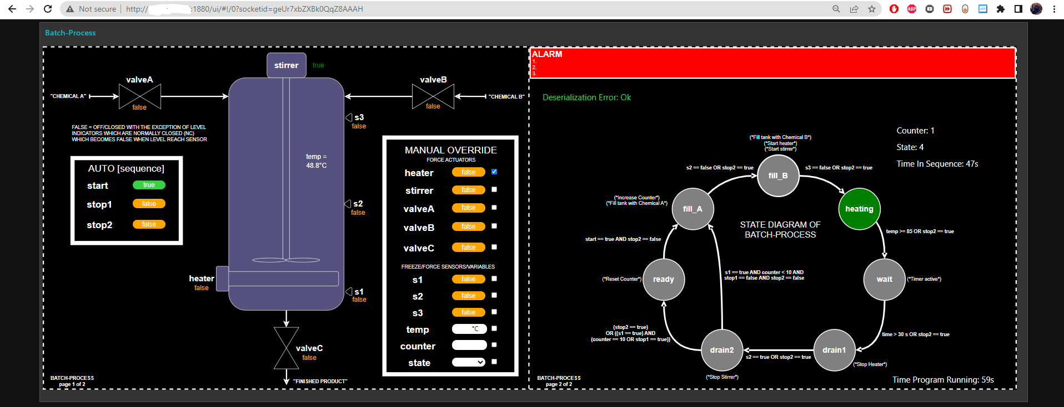  
Note. Figure display some of the features specified in the requirement section 2.9, showing how we can overwrite the “heater” actuator hindering it from increasing tank temperature further and therefore effectively hinder the transaction to the next step in the sequence of being met.

### GUI script description

The GUI script is quite long and non-trivial for people not very familiar with SVG (including myself), the code has just been generated straight from a “drawing” made in draw.io and then copy paste into a template node in Node-RED. But the JavaScript running alongside the SVG inside the template node to make the GUI interactive and actually send a payload message is more compact and was written after the export. This script is described in the next paragraphs. To view the whole code used to display the GUI follow guidelines from Appendix C and then open the “ui_template” node called “Process UI for the Batch-Process”.

This document provides a clear and concise overview of a JavaScript code used for creating an interactive Graphical User Interface (GUI) for the Human-Machine Interface (HMI) layer in an industrial automation system. The code is designed to receive incoming data, update the GUI elements accordingly, and send back the modified data to the control system.

**Key Elements of the Code:**

1. Data Object: The code initializes a 'data' object containing properties for control and sensor values such as start, stop1, stop2, heat, stirr, vA, vB, vC, s1, s2, s3, temp, state, counter, flow, ORM, err, TR, and TIS.
2. DOM Elements: The code identifies and assigns various DOM elements like switch-buttons, input fields, and checkboxes to variables for easy access and manipulation.
3. Payload Handling: The code updates the 'data' object based on the incoming payload and updates the override mode if any override checkboxes are checked.
4. Event Listeners: The code attaches event listeners to the DOM elements, which handle user interactions such as clicks and value changes and update the 'data' object accordingly.

**Main Functionality:**

1. Update Data from Incoming Payload: The function 'updateDataFromIncomingPayload()' updates the 'data' object based on the received payload. It sets the data properties for control and sensor values using the payload data.
2. Update Override Mode: The 'updateOverrideMode()' function checks if any override checkboxes are checked and updates the ORM (Override Mode) property of the 'data' object.
3. Send Data: The 'sendData()' function sends the updated 'data' object back to the control system.

**Event Handling:**

1. Switch Buttons: Event listeners are attached to the switch buttons for handling button clicks. The button state is toggled, and the 'data' object is updated accordingly.
2. Override Checkboxes: Event listeners are attached to the override checkboxes to handle changes in the checkbox state. The 'data' object is updated based on the checkbox state, and the override mode is updated.
3. Temperature Input: Event listeners are attached to the temperature input field to handle value changes. The 'data' object is updated with the new temperature value if the temperature override checkbox is checked.
4. Counter Input: Event listeners are attached to the counter input field to handle value changes. The 'data' object is updated with the new counter value if the counter override checkbox is checked.
5. State Select: Event listeners are attached to the state select dropdown to handle value changes. The 'data' object is updated with the new state value if the state override checkbox is checked.

**Conclusion:**

This document provides a simple and detailed explanation of the JavaScript code designed for creating an interactive GUI for the HMI layer in an industrial automation system. The code receives incoming data, updates the GUI elements, and sends back modified data to the control system. It handles user interactions through event listeners attached to various DOM elements and updates the 'data' object accordingly.

## Process Layer (Node-RED)

### Overview

The process layer is hosted in Node-RED as already seen a little in the Figure 10 is just made up from a process simulation that respond to actuators by updating/modifying sensor values. The field devices the process layer is made up from can be seen in Figure 12.

Figure 12.  
Field devices found in the Process Layer of process “Batch-Process” described in section 5.1.2

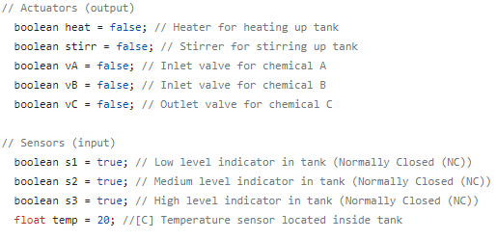

Note. Figure is a screen shot from the Arduino code in the Control Layer from the global declaration part in the beginning of the sketch.

To view the whole process layer code, follow guidelines of Appendix C and then open the “function” node called “Process Simulation”.

### Objective of the Process Layer

The objective of the process layer can be seen in Figure 9. The Process Layer receive information stream “Actuator write” which is the exact same information stream as “Logic force & freeze read” (described in detail in the Main Loop Functions from 5.1.5.1). This “Actuator write” data, also known as “Step 6” enters the Process Layer, specifically the Process Simulation node as we do not have a real process for v1.0. This simulation node is described in the next section, section 5.3.3, and when receiving the updated actuator values from “Step 6” it updates the sensor “field devices” seen in Figure 12. This updated sensor values are sent back to the control layer with “Step 8” also known as “Sensor data read” information stream where the Control Layer can read in the updated sensor values and make logical decisions on them, sending data back to HMI layer going through the cycle again.

### Process simulation description

This document provides an easy-to-understand overview of a process simulation code designed for a water tank control system. The simulation is used to mimic a real-life process in the "process layer" of an industrial automation architecture. The system involves heating, stirring, and controlling the flow of water in a tank. It uses sensor inputs and actuator commands to manage the process and relies on context storage to maintain state information.

**System Components:**

* Constants and Variables: The code defines various constants such as tank capacity, actuator properties, sensor thresholds, and water properties. It also retrieves an initial payload containing input values for actuators and sensors.
* Process and Actuator States: The code initializes the process state with tank volume and temperature and sets actuator states based on the initial payload.
* Tank Volume and Temperature Update: The code updates the tank volume based on valve states and temperature based on heater state.
* Sensor Value Update: The code updates sensor values based on the process state and modifies the initial payload with new sensor values.
* Payload Update and Message Handling: The code updates the message payload, stores updated process states, and sets a flow ID for identification purposes.

**Main Process:**

The main process consists of several steps that update the tank volume, temperature, and sensor values based on actuator states and process state:

1. Define constants and variables: The code begins by defining constants for tank capacity, actuator properties, sensor thresholds, water properties, and retrieving the initial payload.
2. Get process and actuator states: The code initializes the process state (tank volume and temperature) and defines actuator states (valves, heater, and stirrer) based on the initial payload.
3. Update tank volume: The tank volume is updated based on the valve states. If valve A or B is open, the tank volume increases. If valve C is open, the tank volume decreases.
4. Update temperature: The temperature is updated based on the heater state. If the heater is on, the temperature increases. If the heater is off and specific conditions are met, the temperature decreases at a defined cooling rate.
5. Update sensor values: The code updates the sensor values (s1, s2, s3, and temp) based on the process state (tank volume and temperature) and modifies the initial payload with these new values.
6. Reset tank volume and temperature: The code resets the tank volume and temperature to default values when the tank is emptied, based on sensor values.
7. Update message payload: The code updates the message payload, stores updated process states for future iterations, and sets a flow ID for identification purposes. Finally, it returns the updated message object.

**Conclusion:**

This document provides a simplified explanation of a process simulation code designed for a water tank control system. The simulation mimics a real-life process in the "process layer" of an industrial automation architecture. The system involves heating, stirring, and controlling the flow of water in a tank using sensor inputs and actuator commands, updating the tank volume, temperature, and sensor values accordingly.

## Reflection for next iterations

### Report of iteration 1.0 version 1.0 (v1.0 & i1.0)

Introduction:  
The primary goal of this thesis is to study, develop, and test an industrial automation architecture using open-source software and hardware. The intended outcome of version 1.0 is a working architecture that can control an example process from a web-based GUI, read/write to the internet, provide remote operator/engineering capability, enable code alteration without shutdown, and simulate values both locally and remotely. The planned architecture includes the use of Dgraph, Raspberry Pi, Node-RED, and Arduino.

Goals Achieved:

* The solution provides an interactive process operator GUI, displaying real-time values without lag and allowing process control access.
* The solution supports remote control capabilities.
* The solution is suitable for small automation projects and can be scaled up for larger projects.
* The solution relies on open-source hardware and software.
* The solution controls an imaginary small process.
* The solution enables the option of simulating imaginary values for transmitter testing.

Goals Not Met:

* Implementing a data storage layer (database) using Dgraph, which prevented data plotting functionality.
* Sending data to a database and other servers.
* Updating the solution by automation engineers without shutdown (control code, etc.).

Reflection:  
The first iteration of our industrial automation architecture met most of the requirements outlined in section 2.7. The system provides an interactive GUI for process operators, supports remote control, caters to small and large-scale automation projects, relies on open-source hardware and software, controls an imaginary process, and allows for simulating imaginary values for testing purposes.

However, three key requirements were not met in this iteration: implementing the data storage layer using Dgraph, sending data to a database and other servers, and updating the solution without shutdown. Challenges faced in implementing the data storage layer using Dgraph affected our ability to send data to a database and other servers, as well as the intended data plotting functionality.

Lessons learned in iteration 1.0 are documented as code comments in our various scripts and sketches. The primary lessons include avoiding memory fragmentation and dynamic memory allocation, as well as the necessity of handshake agreements for serial communication between the control and HMI layers to prevent packet loss and data transmission errors.

Next Steps:  
For the next iteration we will focus on:

1. Successfully implementing the data storage layer using Dgraph and developing a robust method to send data to a database and other servers, thereby enhancing the system's overall functionality and data management capabilities.
2. Researching and implementing a strategy that allows automation engineers to update the control code without shutting down the system, increasing the solution's reliability and operational efficiency.
3. Applying the lessons learned from iteration 1 to enhance the stability and performance of the system, such as addressing memory management issues and ensuring reliable serial communication between layers.

In conclusion, the first iteration of our industrial automation architecture yielded promising results, but there is room for improvement. By focusing on the unmet requirements, applying the lessons learned, and refining our approach, we can develop a more robust and versatile industrial automation architecture in the subsequent iterations.

# Environmental Impact Analysis

This section provides a brief environmental impact analysis of the proposed open-source industrial automation architecture compared to a traditional setup. The main objective is to identify potential environmental impacts while considering the project as a whole, including the implementation of the suggested changes in processes, equipment, or operational procedures.

1. Energy Consumption: The use of Raspberry Pi and Arduino devices may lead to reduced energy consumption compared to traditional industrial automation systems. These devices are known for their low power consumption, which could result in a smaller environmental footprint.
2. Resource Consumption: Utilizing open-source hardware and software may lead to decreased resource consumption. These devices can be easily updated, modified, or repurposed, which could help reduce electronic waste in the long run.
3. Pollution: The potential for pollution as a result of system malfunction or mismanagement should be considered. While open-source solutions offer flexibility and cost savings, they may not always have the same level of reliability as proprietary systems. In case of failure or malfunction, processes might not be adequately controlled, leading to an increased risk of pollution or other environmental hazards.
4. Noise: The use of open-source hardware, such as Raspberry Pi and Arduino, may not significantly impact noise levels in an industrial setting. These devices are generally quiet and should not contribute to increased noise pollution.

Overall, the open-source industrial automation architecture has the potential to offer environmental benefits in terms of energy and resource consumption. However, it is essential to ensure system reliability to mitigate the risk of pollution and other environmental hazards resulting from system malfunctions. Proper monitoring and maintenance of the system, as well as rigorous testing of the implemented changes, will be crucial to minimize any negative environmental impacts.

# Conclusion of thesis

In conclusion, this thesis presents a comprehensive study, development, and testing of an open-source industrial automation architecture. The architecture utilizes various open-source hardware and software components, including Raspberry Pi, Node-RED, Arduino, and Dgraph, with a focus on scalability, remote control capabilities, and ease of updating without system shutdowns.

The proposed architecture has been iteratively developed, with the first iteration (v1.0 & i1.0) achieving several goals, including an interactive GUI for process operators, support for remote control, suitability for small and large-scale automation projects, control of an imaginary process, and simulation of imaginary values for testing purposes. However, some goals were not met, such as implementing the data storage layer using Dgraph, sending data to a database and other servers, and updating the solution without shutdown.

Future iterations will address the unmet goals, enhance system functionality and performance by refining the architecture, and apply lessons learned from the first iteration. These improvements include successfully implementing the data storage layer using Dgraph, researching and implementing strategies for updating the control code without shutting down the system, and addressing memory management and reliable serial communication between layers.

Additionally, the environmental impact analysis suggests that the open-source industrial automation architecture offers potential benefits in terms of energy and resource consumption. However, it is crucial to ensure system reliability to minimize the risk of pollution and other environmental hazards resulting from system malfunctions. Proper monitoring, maintenance, and rigorous testing of the implemented changes will be essential to minimize any negative environmental impacts.

In summary, the thesis presents a promising foundation for an open-source industrial automation architecture that has the potential to revolutionize the field by offering more accessible, cost-effective, and environmentally friendly solutions. By addressing the unmet requirements, refining the architecture, and focusing on reliability and environmental sustainability, this architecture can pave the way for more innovative and sustainable industrial automation systems in the future.

# How to participate / How to run repository data

## Guide

1. Download the repository from GitHub to your git folder. For my PC which is running Windows I use GitHub Desktop while for the Raspberry Pi 4 which hosts both the Node-RED server and which I use to write Arduino sketch (control logic) to the Arduino UNO board on I use Git.

2. From your now local git repository folder copy the path of to the node-red flow, “gitflow.json”, and paste this into the Node-RED server file “settings.js”. Inside this settings file we can set which flow the Node-RED should open when we start the server, in our case working on the repository we of course want to open the “gitlflow.json” file. One could also copy libraries containing the nodes one has used as well to the Node-RED server config folder, but I find its easiest to just redownload when starting from fresh Node-RED server and only make it open the “gitflow.json” flow from the git repository folder and let the remaining files stay.

3. Open Arduino IDE 1.x (given that is what you have settled to use as well) and download the library used in our Arduino sketch code, the ArduinoJson library. For iteration 1 we have used v6 of this library, but I assume it will be backwards compatible and see no harm in at least trying to run sketch with newer versions of this library given its availability.   
  
4. Have fun, play around with your own ideas and if you are happy with your branch, please send a push request!

## Guidelines

From an interview of Elon Musk by EverydayAstronaut (2021), we have adopted three rules that should be applied at all times when working toward a new version/iteration. These are:

1. Make the requirements less dumb.

“The requirements are definitely dumb; it does not matter who gave them to you. It’s particularly dangerous when they come from an intelligent person, as you may not question them enough. Everyone’s wrong. No matter who you are, everyone is wrong some of the time. All designs are wrong, it’s just a matter of how wrong.” (EverydayAstronaut, 2021, 13:18)

2. Try And Delete Part of The Process

“Try very hard to delete the part or process. If parts are not being added back into the design at least 10% of the time, [it means that] not enough parts are being deleted. The bias tends to be very strongly toward ‘let’s add this part or process step in case we need it’. Additionally, each required part and process must come from a name, not a department, as a department cannot be asked why a requirement exists, but a person can.” (EverydayAstronaut, 2021, 13:54)

3. Simplify Or Optimize

“Simplify and optimize the design. This is the most common error of a smart engineer — to optimize something that should simply not exist.” (EverydayAstronaut, 2021, 17:18)

An idiot admires complexity, a genius admires simplicity (Davis, n.d.)

This applies to the whole project; my requirements and solutions are by far not the best one and by following the guidelines above I hope you can help me and the community to improve it.

# Bibliography

Amazon. (2021). Amazon RDS User Guide. Retrieved January 21, 2023, from <https://docs.aws.amazon.com/AmazonRDS/latest/UserGuide/Welcome.html>

Arduino. (2023). Arduino Opta. Retrieved January 21, 2023, from <https://www.arduino.cc/pro/hardware-arduino-opta>

Arduino. (n.d.). Documentation. Arduino. Retrieved January 21, 2023, from [https://docs.arduino.cc/?_gl=1*1188x6a*_ga*MTc4OTE3NTg1NC4xNjc0MzQ3Mjk5*_ga_NEXN8H46L5*MTY3ODUzODQ4Ny40LjEuMTY3ODU0MDMwOC4wLjAuMA](https://docs.arduino.cc/?_gl=1*1188x6a*_ga*MTc4OTE3NTg1NC4xNjc0MzQ3Mjk5*_ga_NEXN8H46L5*MTY3ODUzODQ4Ny40LjEuMTY3ODU0MDMwOC4wLjAuMA)

Arduino. (n.d.). switch...case. Arduino Reference. Retrieved March 14, 2023, from <https://www.arduino.cc/reference/tr/language/structure/control-structure/switchcase/>

Davis, T. (n.d.). "An idiot admires complexity; a genius admires simplicity" [Quotation]. Retrieved May 14, 2023, from <https://www.goodreads.com/quotes/10480697-an-idiot-admires-complexity-a-genius-admires-simplicity-a-physicist>

EnterpriseAppsToday.com. (2022, June 10). Linux Statistics. Retrieved January 24, 2023, from <https://www.enterpriseappstoday.com/stats/linux-statistics.html>

EverydayAstronaut. (2021, August 3). Starbase Tour with Elon Musk [PART 1 // Summer 2021] [Video file]. Retrieved from <https://www.youtube.com/watch?v=t705r8ICkRw&t=1495s&ab_channel=EverydayAstronaut>

Hanssen, D. H. (2015). Programmerbare logiske styringer - basert på CoDeSys, en praktisk tilnærming til standarden IEC 61131-3 (4th ed.). Fagbokforlaget.

IEC 61131-3." Wikipedia, The Free Encyclopedia. Wikimedia Foundation, Inc. 26 October 2021. Retrieved March 19, 2023, from <https://en.wikipedia.org/wiki/IEC_61131-3>

kansaandre. (2023). Development of an industrial automation architecture using open-sourced hardware software [Source code]. Retrieved May 14, 2023, from <https://github.com/kansaandre/Development-of-an-industrial-automation-architecture-using-open-sourced-hardware-software>

MySQL. (n.d.). MySQL documentation. Retrieved January 21, 2023, from <https://dev.mysql.com/doc/>

Node-RED. (n.d.). Documentation. Retrieved January 21, 2023, from <https://nodered.org/docs/>

OpenPLC Project. (n.d.). OpenPLC overview. Retrieved March 11, 2023, from <https://openplcproject.com/docs/openplc-overview/>

Opensource.com. (n.d.). What is open source? Retrieved January 21, 2023, from <https://opensource.com/resources/what-open-source>

Raspberry Pi. (n.d.). Documentation. Retrieved January 21, 2023, from <https://www.raspberrypi.com/documentation/>

Tango Controls. (n.d.). Overview. Retrieved March 14, 2023, from <https://tango-controls.readthedocs.io/en/latest/development/overview.html>

TechTarget. (n.d.). Software. Retrieved January 21, 2023, from <https://www.techtarget.com/searchapparchitecture/definition/software>

TechTerms. (n.d.). Hardware. Retrieved January 21, 2023, from <https://techterms.com/definition/hardware>

Appendix

1. Project Reflection

In this project reflection, we evaluate the processes and choices made while developing and testing an open-source industrial automation architecture. Throughout the project, we have learned valuable lessons in system design, collaboration, and project management.

What worked well:

1. Leveraging open-source technologies: The use of Raspberry Pi, Node-RED, Arduino, and Dgraph allowed for a flexible and cost-effective solution for industrial automation.
2. Remote control capabilities: The architecture successfully provided remote control access and real-time interaction through an intuitive GUI.
3. Collaboration: Utilizing GitHub as a platform enabled effective communication, iteration, and participation from people worldwide.

What we would do differently next time:

1. Data storage implementation: More attention should be given to the implementation of the data storage layer using Dgraph, as it was not achieved in the first iteration.
2. System reliability: We would prioritize improving system reliability to ensure seamless updating of the control code without shutting down the system.
3. Time management: Allocate more time for researching and testing different methods and tools to address the challenges encountered in the first iteration.

Comparing the intended goals from the pre-project with the goals achieved in the project report, we have made significant progress, but there is still room for improvement. Regular updates of the plan, including the Gantt chart, have been instrumental in tracking progress and adjusting our approach.

In conclusion, the experiences gained from this project will be invaluable for future projects. By reflecting on our processes, choices, and lessons learned, we can better approach the next project with more insight and expertise, driving innovation and success in open-source industrial automation architecture development.

1. Control Layer (Arduino) Code for v1.0 & i1.0

Figure 13.  
Location of code that is used in our Control Layer running on our Arduino UNO microcontroller

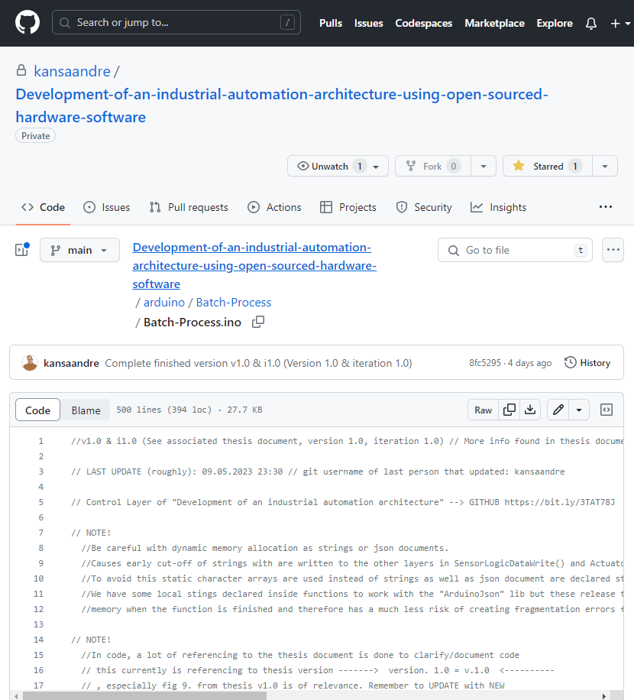  
Figure is a screenshot of our Control Layer code location in our GitHub repository accessible from Development of an industrial automation architecture using open-sourced hardware software (2023). Written in Arduino language also known as modified C++.

1. HMI/SCADA Layer (Node-Red) Code for v1.0 & i1.0

Figure 14.  
Location of code in this projects GitHub repository that is used in our HMI/SCADA Layer running on our Raspberry Pi 4 micro computer

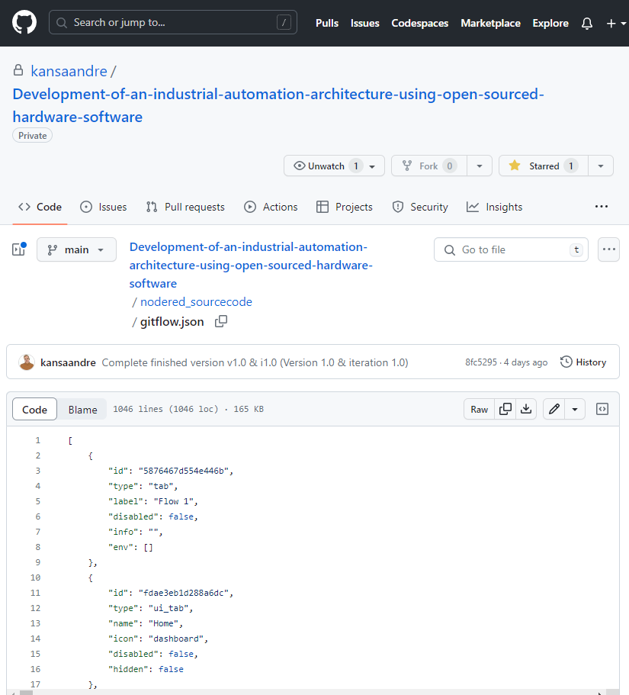

Figure 14 is a screenshot of our HMI/SCADA layer code location in our GitHub repository accessible from Development of an industrial automation architecture using open-sourced hardware software (2023). Written in JSON also known as JavaScript Object Notation Language that is converted to nodes when imported to Node-Red and will be graphically viewable and editable as seen in Figure 10.

The GUI (Graphical User Interface) itself is written in SVG/HTML, JavaScript and CSS and is located inside the node “Process UI for the Batch-Process” seen in Figure 10.

The Process is simulated in Node-RED as well in the node “Process Simulation” seen in Figure 10. Note that process simulation is part of Process Layer not HMI Layer